### VILLAGE OF BERRIEN SPRINGS ORDINANCE NUMBER 357

AN ORDINANCE TO AMEND APPENDIX B ENTITLED "ZONING", ARTICLE XVI OF THE VILLAGE CODE ENTITLED "SPECIAL PROVISIONS", TO ADD A NEW SECTION 16.07 TO BE ENTITLED "BERRIEN SPRINGS/ORONOKO TOWNSHIP (BSOT) JOINT PLACE BASED CODE OVERLAY DISTRICT FOR THE M-139 CORRIDOR"

NOW THEREFORE, The Village of Berrien Springs ordains:

WHEREAS, the M-139 Corridor Improvement Plan recommended changes to the Zoning Ordinances of the Village to provide more flexibility in the Zoning Code for the M-139 Corridor, in the form of a Joint Place Based Code Overlay District for the M-139 Corridor, and

WHEREAS, the Village Council finds the adoption of the Joint Place Based Code Overlay District as it applies to the applicable parcels is consistent with the Village of Berrien Springs Master Plan and the M-139 Corridor Improvement Plan and is otherwise in keeping with public health, safety and general welfare of the Village.

Section 1.

Appendix B entitled "Zoning", Article XVI of the Village Code entitled "Special Provisions", is hereby amended to add a new Section 16.07, to be entitled "Berrien Springs/Oronoko Township (BSOT) Joint Place Based Code Overlay District for the M-139

Corridor"1, which shall read as follows:

Section 16.07.

1 Also known as the Berrien Springs/Oronoko Township (BSOT) Place Based Code.

lo



### TITLE AND LEGAL BASIS

This Ordinance shall be known as the Berrien Springs/Oronoko Township (BSOT) Joint Place Based Code for the M-139 corridor. It is established pursuant to the provisions of the Michigan Zoning Enabling Act (PA 110 of 2006), as amended, and the Michigan Joint Municipal Planning Act PA 226 of 2003), as amended.

### PURPOSE AND SCOPE

The BSOT Joint Place Based Code is intended to support and foster new development and redevelopment along the M-139 Corridor in the Village of Berrien Springs and Oronoko Charter Township. Through the establishment of zones, frontage types and thoroughfare guidelines, development and redevelopment will be compact and pedestrian-oriented and foster walkable corridors with mixed uses. It is further the purpose of this Joint Place Based Code to allow a wider range of permitted and special land uses than what would otherwise be allowed under the existing municipal zoning ordinance, when such uses are designed and constructed in a manner that is consistent with the vision outlined in the BSOT M-139 Corridor Improvement Plan.

The BSOT Joint Place Based Code reflects the desires and outcomes of the BSOT M-139 Corridor Improvement Plan. All new development and redevelopment, as outlined in Section 01.03, within the Place Based Code overlay district shall adhere to the provisions and standards established herein to realize the vision set forth in the Oronoko Charter Township Master Plan, the Village of Berrien Springs Master Plan and the BSOT M-139 Corridor Improvement Plan adopted by the Oronoko Charter Township Board on , 2015 and by the Berrien Springs Village Council on February 2, 2015. This Joint Place Based Code shall be jointly administered by the Village and Township, which shall include formation of a joint Zoning Board of Appeals, as set forth in Section 02.05 of this Place Based Code.

This BSOT Place Based Code is a legal document regulating building, frontage, and thoroughfare types along with other aspects of land development for properties in the Village of Berrien Springs or Oronoko Charter Township within the Place Based Code (PBC) overlay district. It shall regulate those properties, in conjunction with the municipal Zoning Ordinances, for areas within the Place Based Code overlay (PBC) on the zoning map. Properties not within the Place Based Code overlay district shall continue to be regulated by the applicable municipal Zoning Ordinance.

In instances where the provisions of the applicable municipal Zoning Ordinance conflict with the provisions of this BSOT Joint Place Based Code, the BSOT Joint Place Based Code shall control. For development standards not covered by the BSOT Joint Place Based Code, the other applicable sections in the municipal Zoning Ordinance shall apply. All development shall also comply with all other local, state or federal regulations and ordinances.

### APPUCABIUTY

1. Except as provided in subsection 2 below, the BSOT Joint Place Based Code shall apply to development within the boundaries of the Joint Place Based Code Zoning District as illustrated on the Zone Map.

Development shall include the following:

* 1. New development

1. Modifications to the exterior of existing buildings or structures:
   1. increasing or decreasing the area of a building footprint by fifty percent (50%) or greater.
   2. Exterior modifications or additions to existing buildings or structures such that the cost of the modifications or additions is greater than or equal to sixty percent (60%) of the replacement value of the building or structure at that time. Phased construction to avoid compliance with this standard or breaking up construction such that the thresholds are avoided is prohibited.
2. All additions to the exterior frontages of existing buildings or structures shall, at a minimum, comply with the frontage standards of Section 03.03, and architectural standards of Section 03.04 of this Place Based Code.
3. Where development does not meet the threshold established in A-B above, an applicant may opt to comply with the provisions of the BSOT Place Based Code, although it is not required. In instances where an applicant opts to not comply with the provisions of the BSOT Place Based Code, the requirements of the applicable municipal Zoning Ordinance shall apply.
4. For properties located west of US-31, an applicant may opt to comply with the provisions of the BSOT Place Based Code, although it is not required. In instances where an applicant opts to not comply with the provisions of the BSOT Place Based Code, the requirements of the applicable municipal Zoning Ordinance shall apply.
5. In instances where an applicant opts to comply with the provisions of this Place Based Code, that property shall be required to comply with all requirements of this Place Based Code, and may not "opt out" from the requirements of this code at a later date.

### PBC OFFICIAL ZONE MAP

For the purposes of this Ordinance, the areas within the Place Based Code overlay as illustrated on the applicable municipal Official Zoning Map are hereby organized into the following zones:

* 1. Rural
  2. Neighborhood Edge
  3. Neighborhood General

0-58 Neighborhood Center 0-5A Downtown

The boundaries of each zone are shown on the map entitled "Place Based Code Offical Zone Map" and this map is hereby made a part of this Joint Place Based Code. No changes to the Place Based Code Official Zone Map shall be made without the recommendation of approval from the Joint Planning Commission and without approval from the Oronoko Charter Township Board and the Berrien Springs Village Council, and such amendments shall be adopted in accordance with the Michigan Zoning Enabling Act (PA 110 of 2006), as amended, and the Joint Municipal Planning Act (PA 226 of 2003), as amended.

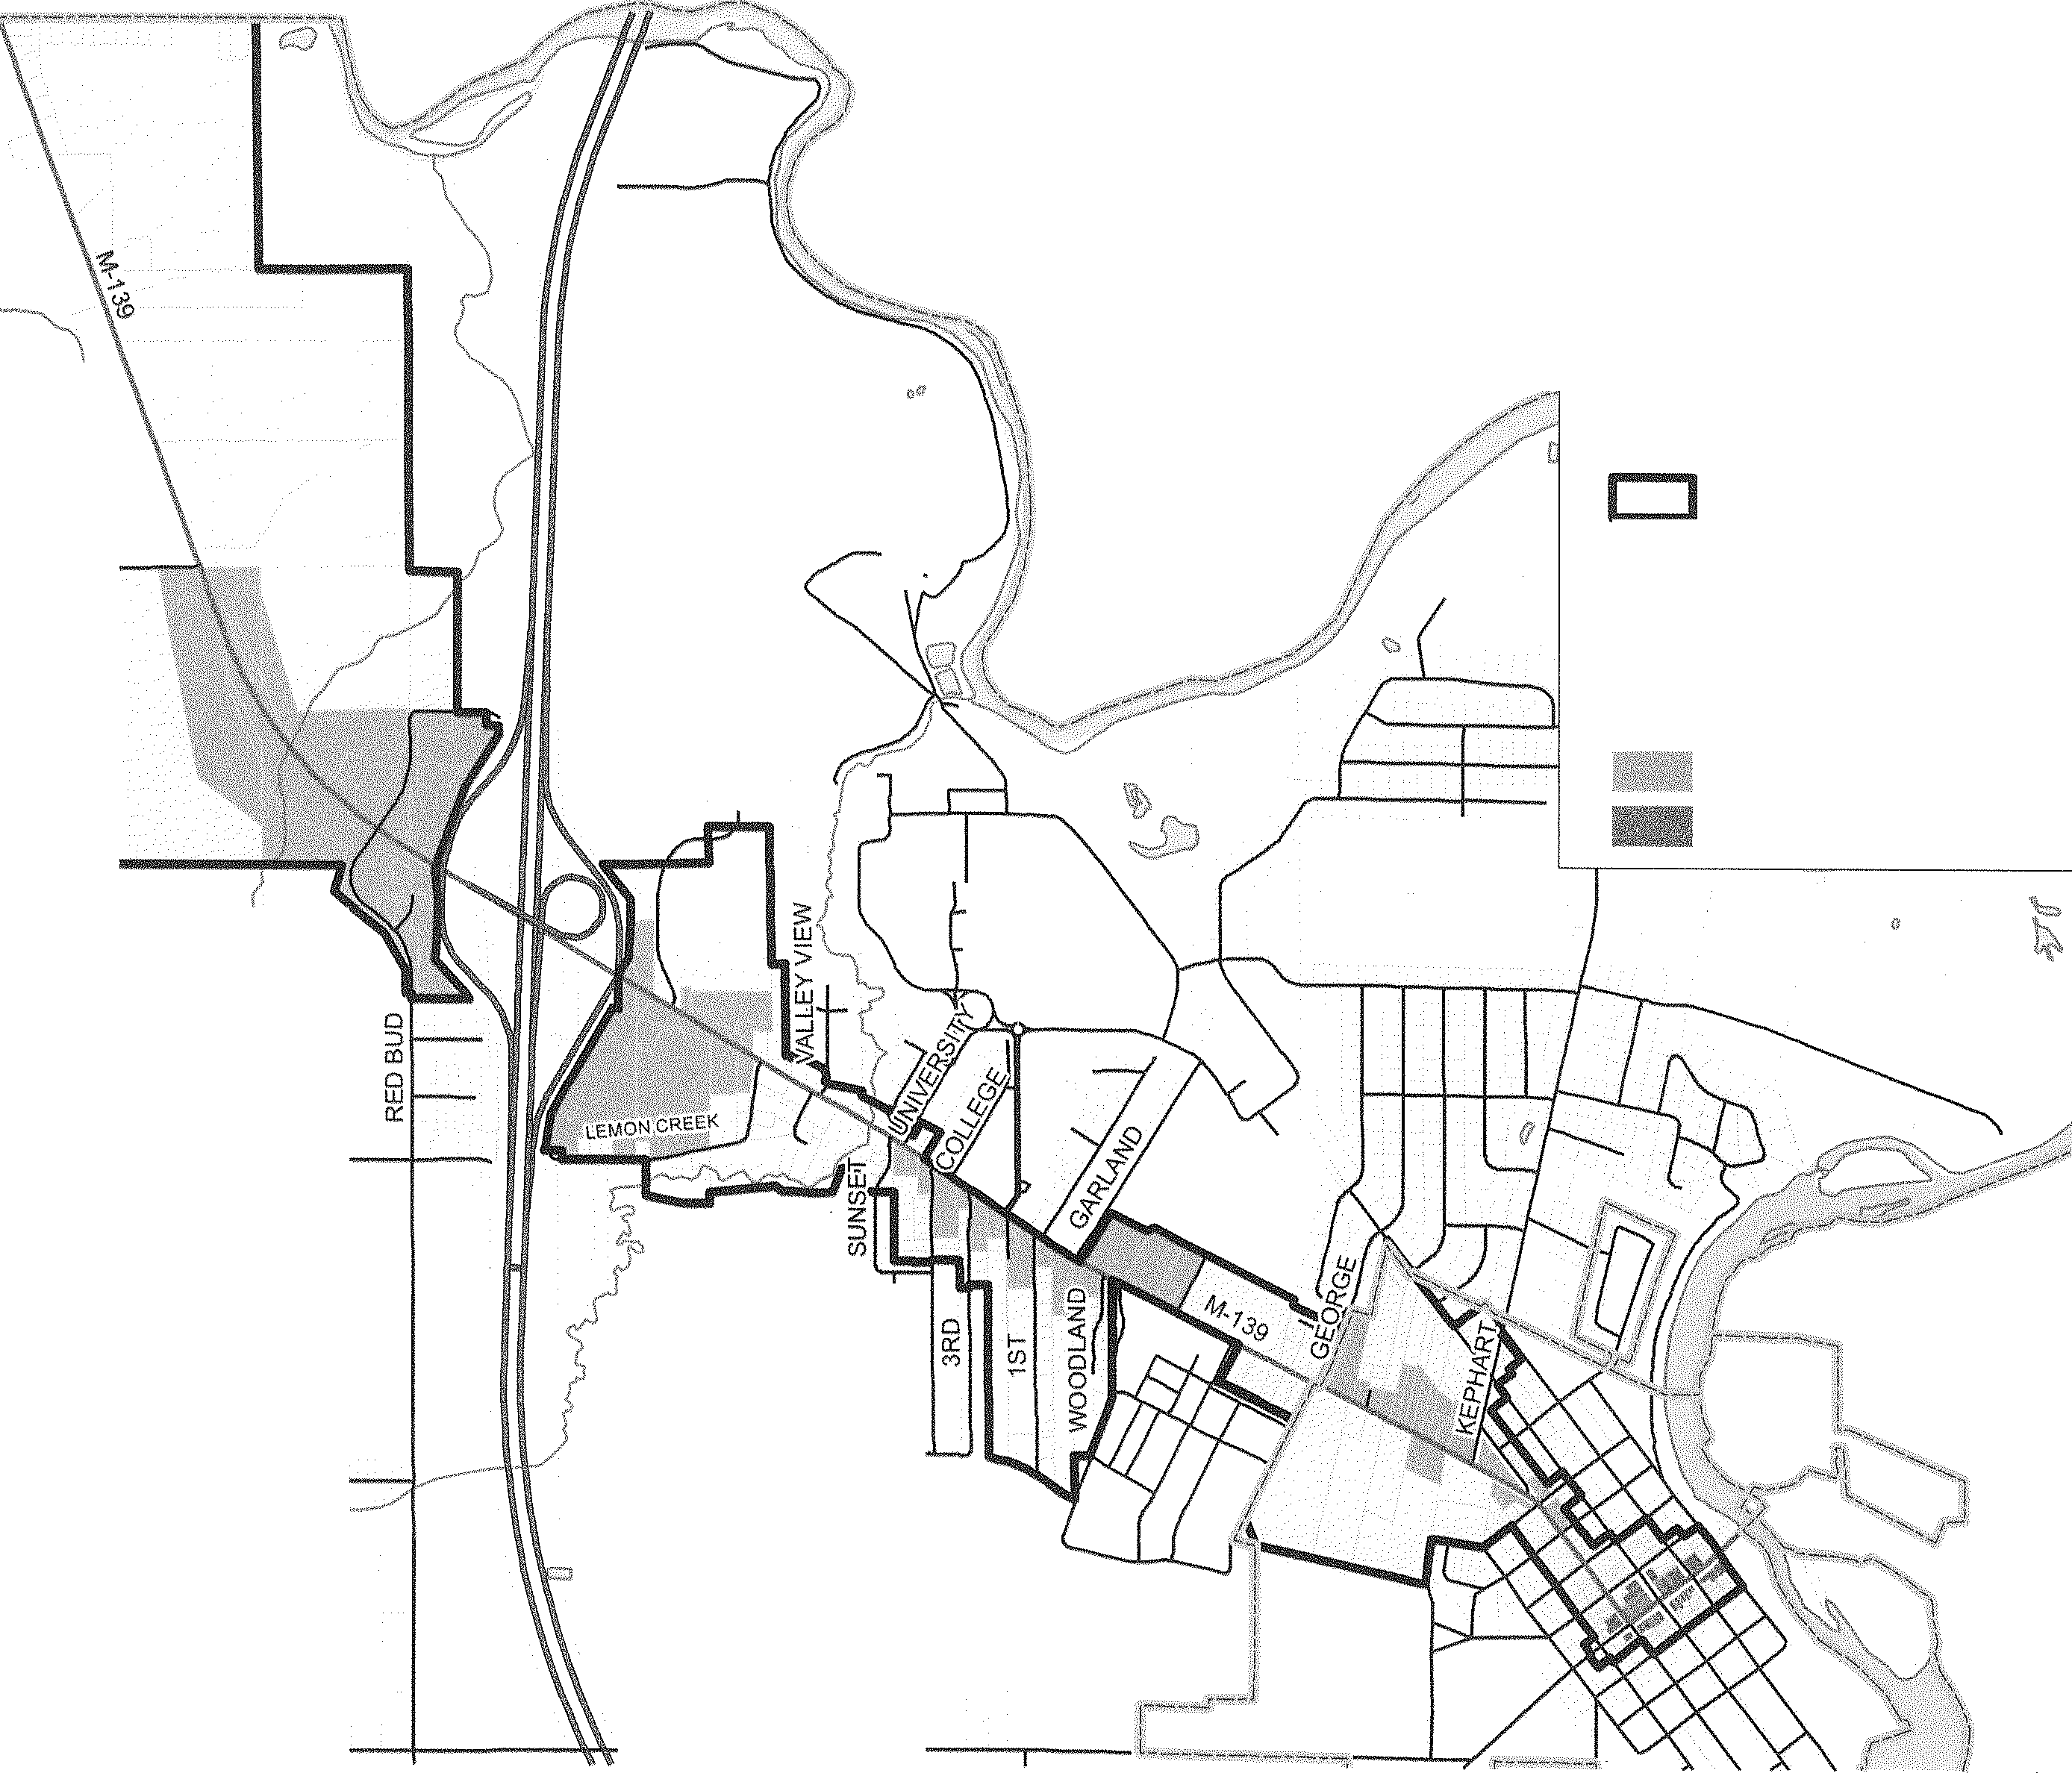

LINCO Adopted by Oronoko Charter Township: _

Village of Berrien Springs Oronoko Charter Township

Be ni f!n C o un ty, Mi chi ga n

Place Based Code Official Zone Map

Adopted: , 201 5

Effective: , 20 1 5

Legend

PBC Overlay District

Place Based Code Zones

02, Rural

03, Neighborhood Edge

04, Neighborhood General

058, Neighborhood Center 05A, Downtown

Effective in Oronoko Charter Township: _

Adopted by Village of Ben·ien Springs: _ Effective in the Village of Berrien Springs:

I inch 2.000 feet

0 1 .onn 2,000 4.000

m11111=::1111mc:::J111111!!!llllil!!!llllil!!!llllil!!!llllilllll!llillll/lllllll1Feet

\Villiams . \Vork

HINCHMAN

LEMON CREEK

t(L/J) I I

z 1-

:::i 'tj" (/)



### CHAPTER 2. PROCEDURES

* 1. SITE PLAN REVIEW

1. Site Plan Required. For development within the Place Based Code Zoning District pursuant to Section 01.03, including Special Land Uses and Special Area Plans, site plan review and approval by the applicable reviewing body(ies) is required. Site plans shall contain all data and information required by the applicable municipal Zoning Ordinance.
2. ocal Review.The Zoning Administrator shall be the reviewing body for uses permitted by right, including special area plans. The Zoning Administrator shall notify the Joint Planning Commission of submitted site plans and/or special area plans during regular Joint Planning Commission meetings.
3. Special Land Uses. In the case of Special Land Uses, the Joint Planning Commission shall be the reviewing body. In reviewing special land use request, the Joint Planning Commission shall apply the special land use review standards of the applicable municipal Zoning Ordinance, along with the standards of this Place Based Code.
4. Special Area Plans. The Zoning Administrator shall be the reviewing body for special area plans. For special area plans that contain a special land use(s), the procedures for Special Land Use application and review under subsection (3) above shall be applied for that part of the special area plan containing the special land use(s).
5. When reviewing and deciding whether to approve a site plan, special land use, special area plan or other request within the Place Based Code overlay, the applicable reviewing body shall apply the appropriate standards of the applicable municipal Zoning Ordinance, and shall also be guided by the following standards:
   1. If the proposed development supports the preservation of the region's natural infrastructure and visual character derived from topography, farmlands, and waterways.

8. If the proposed development is compact and pedestrian-oriented.

1. If proposed thoroughfares are designed to disperse and reduce the length of automobile trips.
2. If proposed housing units provide a range of housing types and price levels to accommodate diverse ages and incomes.
3. If the proposed development includes a range of civic space including parks, plazas, and playgrounds, distributed within neighborhoods and town centers.
4. If proposed buildings and landscaping contribute to the physical definition of existing or proposed thoroughfares as civic places.
5. If the proposed development adequately accommodates automobiles while respecting the pedestrian and the spatial form of public areas.
6. If the design of proposed thoroughfares and buildings reinforces safe environments, but not at the expense of accessibility.

### DEPARTURES FROM PLACE-BASED CODE STANDARDS

1. Minor Departures. The Zoning Administrator may, at the request of an applicant, authorize minor departures from certain standards contained in this Place Based Code. Minor departures shall include, but are not limited to, the following:
   1. A departure of up to 5 feet in a required front, side or rear yard setback requirement
2. A departure of up to 10% of a required maximum lot coverage requirement
3. A departure of up to 5% of a primary street facade built-to setback
4. A departure of up to 10% of a side street facade built-to setback
5. A departure of up to 5% of a transparency requirement

Findings for Minor Departures. In order to grant a minor departure, the Zoning Administrator shall find that all of the following conditions are met:

A The minor departure does not materially change the circulation and building location on the site;

1. The minor departure does not alter the relationship between the buildings and the street;
2. The minor departure does not allow a use not otherwise permitted in this Place Based Code, and;

D. The proposed development meets the intent of this Place Based Code and is consistent with the BSOT M-139 Corridor Improvement Plan.

1. Major Departures. Major departures shall be considered any departure from the provisions of this Place Based Code that are not considered minor departures. The BSOT Joint Zoning Board of Appeals may, at the request of the Zoning Administrator or applicant, authorize such major departures. In order to grant a major departure, the BSOT Joint Zoning Board of Appeals shall find that all of the following standards are met
   1. The major departure does not materially change the circulation and building location on the site;
   2. The major departure does not alter the relationship between the buildings and the street;
   3. The major departure does not allow a use not otherwise permitted in this Place Based Code;
   4. The proposed development meets the intent of this Place Based Code found in Section

01.02 of this Chapter and is consistent with the BSOT M-139 Corridor Improvement Plan, and;

In arriving at its decision, the Zoning Board of Appeals shall be guided by the standards of Section 02.01, 5, A-H of this Section, established precedent and good planning practice.

### SPECIAL AREA PLANS

#### A SpecialArea Plan is intended to allow applicants development flexibility to address market conditions and opportunities, including the master planning of large lots exceeding the maximum block dimensions as outlined in Figure 2.1 of this Place Based Code, as well as the consolidation of multiple properties to create predictable and

market-responsive development for the area.

Figure 2.1 Maximum Block Dimensions ZONES MAX. BLOCK

PERIMETER

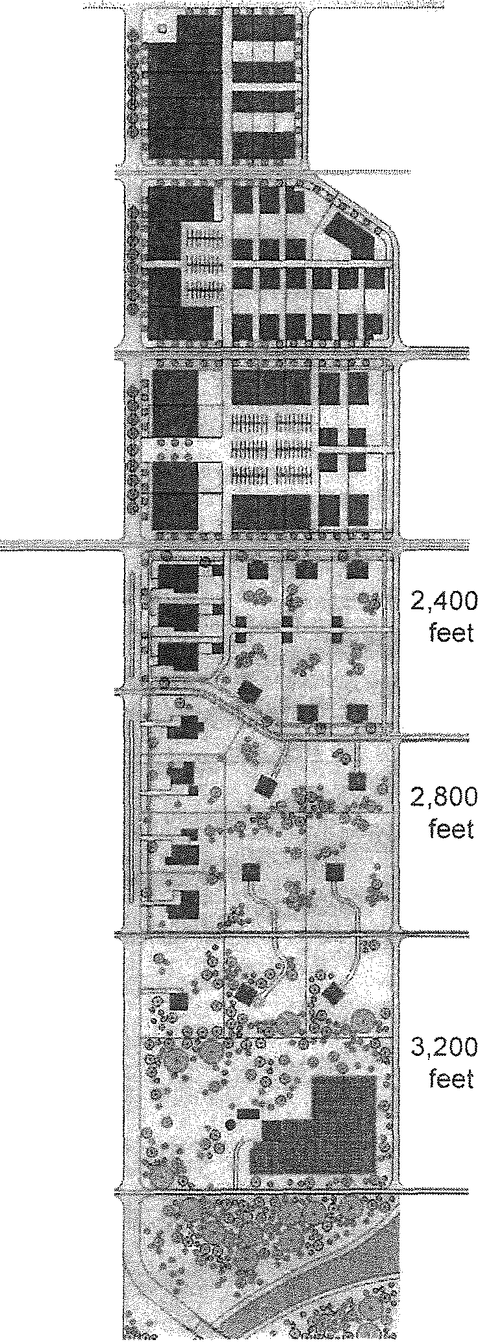

0-5A 1,200

#### Special Area Plans shall contribute to the greater community by extending the existing network of Thoroughfares, creating a network which is

DOWNTOWN

feet

#### interconnected and walkable; shaping Civic Spaces

0-58 1,800

#### which cultivate safety and comfort, and encourage a mix of complementary uses and housing types.

1 A special area plan is required for any development on a parcel(s) of five (5) acres or greater. For developments on parcels less than five (5) acres in area, a special area plan is optional, unless required elsewhere by this Place Based Code.

1. Blocks shall be required in all special area plans greater than 5 acres in area and shall meet the dimensional requirements of Figure 2.1 measured along their entire perimeter. Perimeters shall consist of either Thoroughfares pursuant to Chapter 5 or Civic Spaces pursuant to Section 03.01. Rear alleys may be allocated within blocks but shall not be considered a defining edge of a block within a special area plan.
2. Thoroughfares within special area plans shall contribute to an interconnected network and shall connect to existing street networks where feasible. When adjacent land is undeveloped, thoroughfare networks

NEIGHBORHOOD

CENTER

# 0-4

NEIGHBORHOOD GENERAL

# 0-3

NEIGHBORHOOD EDGE

# 0-2

RURAL

feet

#### should enable their future extension to adjacent properties.

1. Special Area Plans with an area of 20 acres or greater and located west of US-31 shall preserve, in perpetuity, a minimum of 50% of the total area comprising the special area

plan for agricultural purposes or as undeveloped open space. This requirement is in addition to the required 10% for Civic Space established in Section 02.04.

* 1. STANDARDS FOR SPECIAL AREA PLANS

Special Area Plans shall conform to the following requirements:

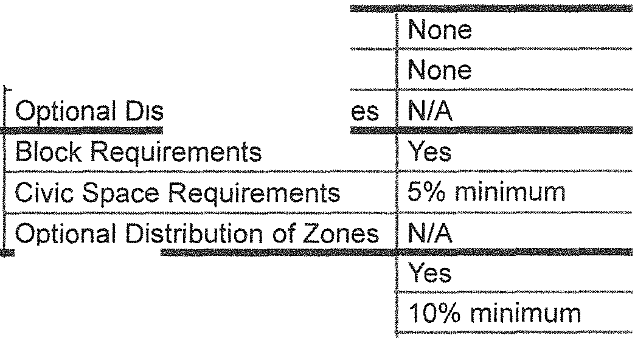

For projects less than 5 acres in area

Special Area Plan optional

For projects between 5 and 20 acres in area

For projects 20 acres in area or greater

Special Area Plan required

S ecial Area Plan Re uirements

Block Requirements

Civic Space Requirements

* tribution of Zon

Special Area

Plan required

ion

Block Requirmen.t_s _ Civic Space Requirements

0-58: 10%-30%

Optional Distribution of Zones* 0-4: 30%-60%

0-3: 10%-30%

* Optional Distribution of Zones: For projects of 20 acres or greater located in any zone, por­ tions of Iand may be developed in accordance with the zone proportions outlined in the above table.

* 1. BSOT JOINT ZONING BOARD OF APPEALS

1. Creation of the Village of Berrien Springs/Oronoko Charter Township ("BSOT") M-139 Joint Zoning Board of Appeals. There is hereby established a BSOT M-139 Joint Zoning Board of Appeals (BSOT ZBA) in accordance with Act 110 of the Public Acts of Michigan of 2006, as amended, being the Michigan Zoning Enabling Act, and in accordance with Public Act 226 of 2003, as amended. The BSOT ZBA shall perform its duties and exercise its powers as provid­ ed by said Act, as amended, and in such a way that the objectives of this Place Based Code may be equitably achieved; that there shall be provided a means for competent interpretation and controlled flexibility in the application of this Code; that the health, safety, and welfare of

the public be secured; and that substantial justice be secured.

1. Membership, Terms of Office. The BSOT ZBA shall consist of seven (7) members. Four (4) of the seven members shall be appointed by the Oronoko Charter Township Board and three

(3) of the members shall be appointed by the Berrien Springs Village Council. One (1) rep­ resentative from the Township shall be a member of the Board of Trustees, and the Trustee's term on the Board shall be concurrent with their term on the Joint Planning Commission. At least one (1) representative from the Village shall be a member of the Village Council, and the Councilmember's term of the Board shall be concurrent with their term on the Village Council. If a ZBA member is also a member of the Joint Planning Commission or legislative board or council, that member cannot participate in a public hearing or vote regarding the same matter that the member voted on as a member of the Joint Planning Commission, board or council.

The Township Board and Village Council shall appoint the remaining members of the Board. The members selected shall be representative of the population distribution and of the various interests present in the BSOT community. An elected officer of the Township or Village shall not serve as Chair of the BSOT ZBA.

The term of office of each member shall be three (3) years. A successor shall be appointed

not more than one month after the term of the preceding member has expired. All vacancies for unexpired terms shall be filled for the remainder of the term. The Village Council and Township Board shall seek to stagger the expiration dates of members of the BSOT ZBA so at least one member's term expires each year and to achieve a reasonable degree of continuity of membership from one year to the next. The Village and Township may appoint at least two

(2) alternate members each, who shall serve for three (3) years.

1. Meetings. Meetings of the BSOT ZBA shall be held at the call of the Chair and at such other times as the Board in its rules of procedure may specify. The Chair, or in his or her absence, the acting Chair, may administer oaths and compel the attendance of witnesses. All meet­ ings of the BSOT ZBA shall be open to the public. The Board shall maintain a record of its proceedings, which shall be filed in the offices of both the Township Clerk and Village Clerk and shall be a public record. The Board shall not conduct business unless a majority of the members of the Board are present.
2. Duties, Rules, Hearing and Decisions of Appeals, Right to and Grounds of Appeal. The BSOT ZBA shall act upon all questions as they may arise in the administration of this Place Based Code, including the interpretation of the Zone Maps, and may fix rules and regulations to gov­ ern its procedures. It shall also hear and decide appeals from and review any order, require­ ment, decision or determination made by the administrative official charged with enforcement of this Place Based Code. It shall also hear and decide all matters referred to it or upon which it is required to pass under this Place Based Code. The concurring vote of a majority of the members of the BSOT ZBA shall be necessary to reverse any order, requirement, decision or determination of any administrative official, or to decide in favor of an applicant any matter upon which they are required to pass under this Place Based Code. Such appeal may be taken by any person aggrieved or by any officer, department, board, commission or bureau of the Township, Village, County, or State. The grounds of every determination shall be stated.
3. Time to and Notice of Appeal: Transmission of Record. Such appeal shall be taken within such time as shall be prescribed by the BSOT ZBA by general rule, by the filing with the Town­ shipNillage Clerk, the Zoning Administrator or other officer from whom the appeal is taken and with the BSOT ZBA of a notice of appeal specifying the grounds thereof together with a fee established by Township Board and Village Council which shall be paid to the Township or Village at the time the notice of appeal is filed. The officer from whom the appeal is taken shall forthwith transmit to the BSOT ZBA all the papers constituting the record upon which the action appealed was taken.
4. Stay of Proceedings Pending Appeal. An appeal shall stay all proceedings in furtherance of the action appealed, except as provided herein. Proceedings shall not be stayed in the event the officer from whom the appeal is taken certifies to the BSOT ZBA, after the notice of appeal is filed, that a stay would cause imminent peril to life or property. The BSOT ZBA or the Circuit Court may issue a restraining order to re-institute a stay on application and notice to the officer from whom the appeal is taken with due cause shown.
5. Hearings and Notices, Right to be Heard, Disposition of Appeals, Decision Not Final. The BSOT ZBA shall fix a reasonable time for the hearing of the appeal and give due notice thereof to the parties and decide the same within a reasonable time. Upon hearing, any party may appear in person or by agent or by attorney. The BSOT ZBA may reverse or affirm wholly or partly, or may modify the order, requirement, decision or determination as in its opinion ought to be made in the premises. Where there are practical difficulties or unnecessary hardship in the way of carrying out the strict letter of this Place Based Code, the BSOT ZBA shall have the

power, in passing upon appeals, to vary or modify any of its rules, regulations or provisions so that the spirit of the Code shall be observed, public safety secured, and substantial justice done. The decision of the BSOT ZBA shall not be final, and any person having an interest affected by this Place Based Code shall have the right to appeal to the Circuit Court.

### DUTIES AND POWERS OF THE ZONING BOARD OF APPEALS

The BSOT ZBA shall not have the power to alter or change the zoning district classification of any property, nor to make any change in the terms of intent of this Ordinance, but does have power to act on those matters where by statute or this Place Based Code provision is made for an admin­ istrative review, interpretation, departure or exception as defined therein.

A Review. The Board shall hear and decide appeals where it is alleged by the appellant that there is an error in any order, requirement, permit, decision or refusal made by the Zoning Administrator or the Joint Planning Commission or by any other official in administering or enforcing any provision of this Place Based Code. The allegation shall be duly made within thirty (30) days of the date of decision being appealed. The date of decision is presumed to be five (5) days after the literal date of decision.

* 1. Interpretation. The BSOT ZBA shall have the power to:
     1. Interpret, upon request, the provisions of this Place Based Code in such a way as to carry out the intent and purpose of the Code.
     2. Determine the precise location of the boundary lines between zones.
  2. Departures. The BSOT ZBA shall have the power to authorize, upon an appeal, major de­ partures from the requirements of this Place Based Code provided it finds that the standards of Section 02.02 (2) are met. The appellant shall submit, along with the established fee and other materials, a narrative demonstrating why a departure is sought. In granting a major departure, the BSOT ZBA shall find that the departure request meets all of the conditions outlined in Section 02.02(2) of this Place Based Code.
  3. Rules. The following rules shall be applied in the granting of major departures:
     1. The BSOT ZBA may specify, in writing, such conditions regarding the character, location, and other features that will in its judgment, secure the objectives and purposes of this Place Based Code. The breach of any such condition shall automatically invalidate the permit granted.
     2. Each major departure granted under the provisions of this Place Based Code shall be­ come null and void unless: The construction authorized by such major departure has re­ ceived a building permit within one (1) year after the granting of the major departure; and the occupancy of land, premises, or buildings authorized by the major departure has taken place within one (1) year after the granting of the major departure, unless an extension of time has been granted by the BSOT ZBA
     3. No application for a major departure which has been denied wholly or in part by the board shall be re-submitted for a period of one (1) year from the date of the last denial, except on the grounds of newly discovered evidence of changed conditions found, upon inspection by the BSOT ZBA, to be valid. For such newly discovered evidence to be considered, an applicant shall submit a detailed description of such evidence to the Zoning Administrator

who shall place it on the agenda of the BSOT ZBA along with a report and recommen­ dation on the nature of such newly discovered evidence and whether it may have been pertinent to the decision of the BSOT ZBA. If the BSOT ZBA determines that the newly discovered evidence would have been pertinent to its decision, it shall direct the Zoning Administrator to accept a new application for the previously denied major departure. An application considered under the terms of this subparagraph shall be considered a new application and shall be subject to all hearing, notice and fee requirements of the applica­ ble municipality.

* 1. Performance Guarantee. In authorizing any major departure, or in granting any conditional, temporary or special approval permits, the BSOT ZBA may require that a performance guar­ antee be furnished to insure compliance with the requirements, specifications and conditions imposed with the grant of major departure or permit and to insure the discontinuance of a temporary use by a stipulated time. Such performance guarantee may be in the form of a cash deposit, certified check, or irrevocable bank letter of credit, at the discretion of the BSOT ZBA.



* 1. CIVIC SPACE



throughout

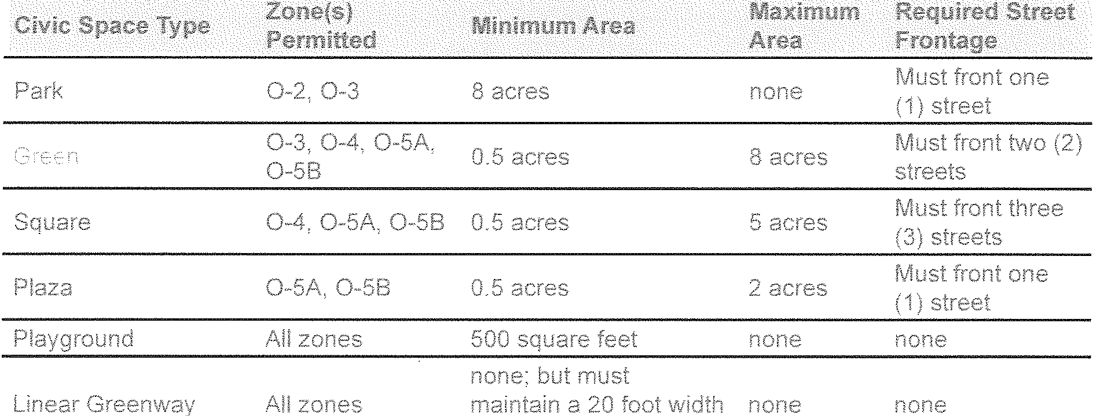

### STREETSCAPES























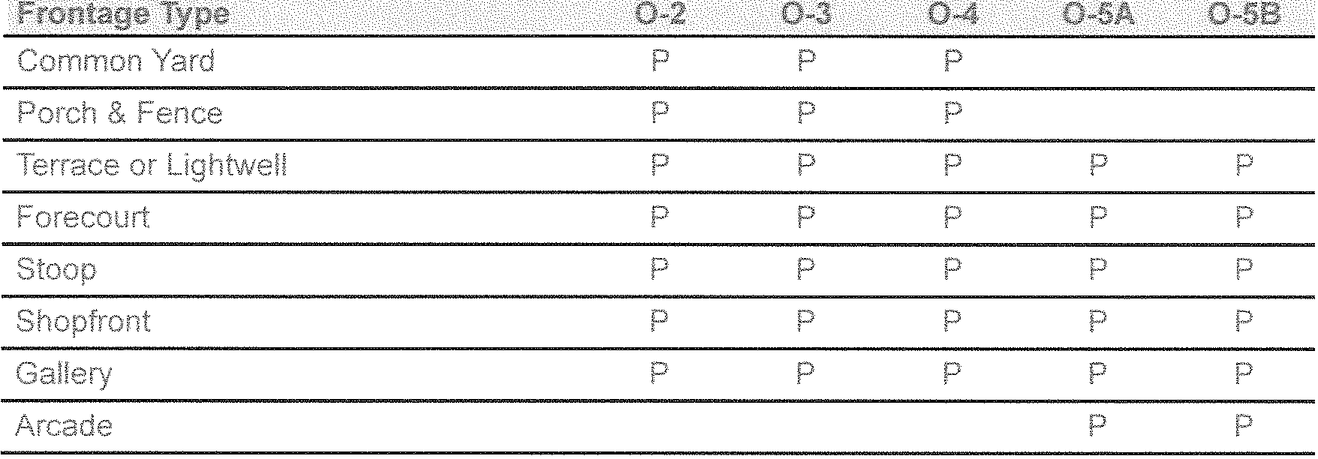



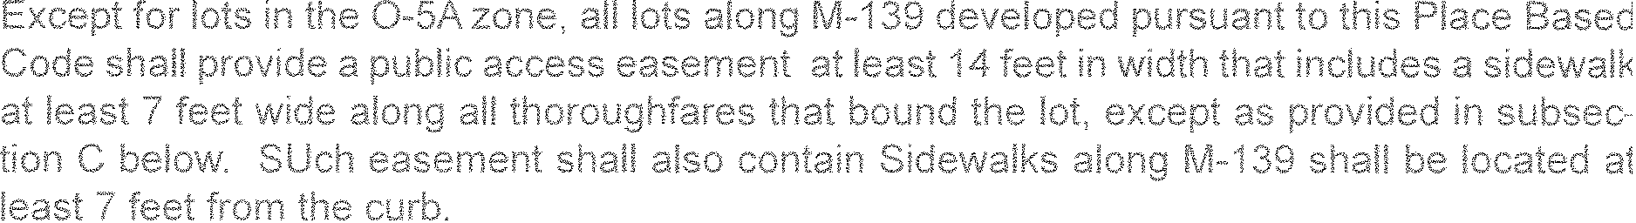





Definition Regulations

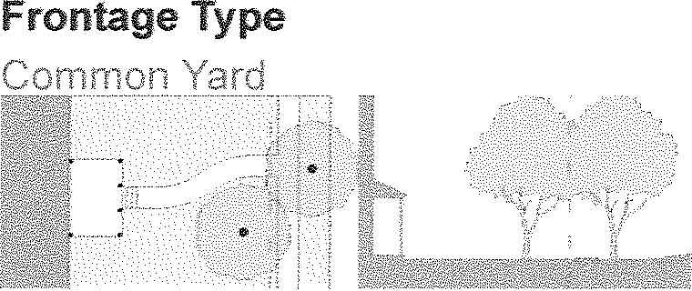



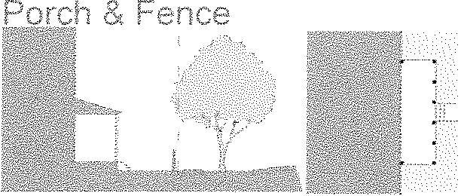  

  

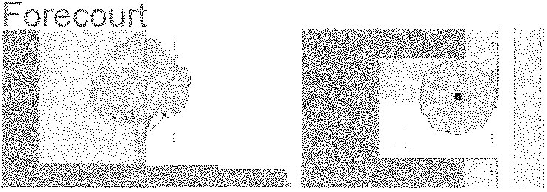 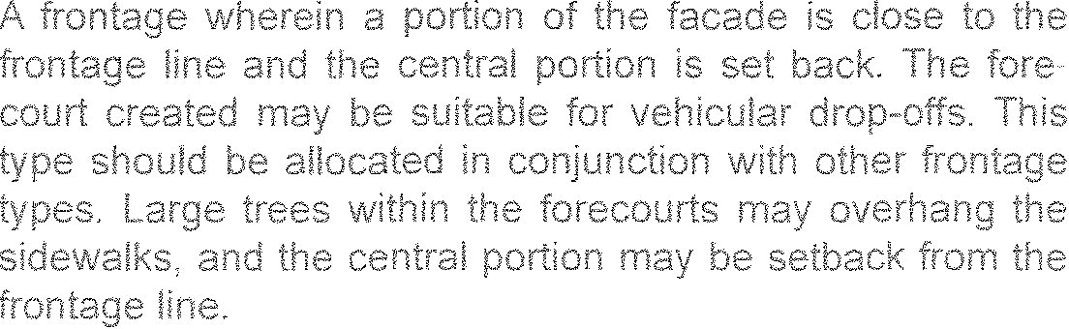

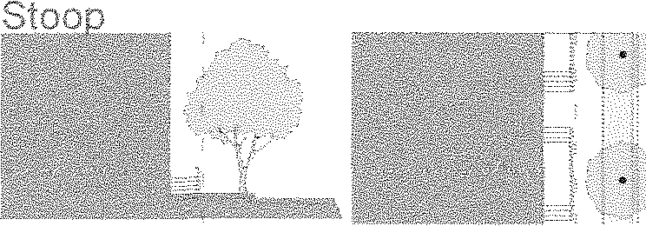 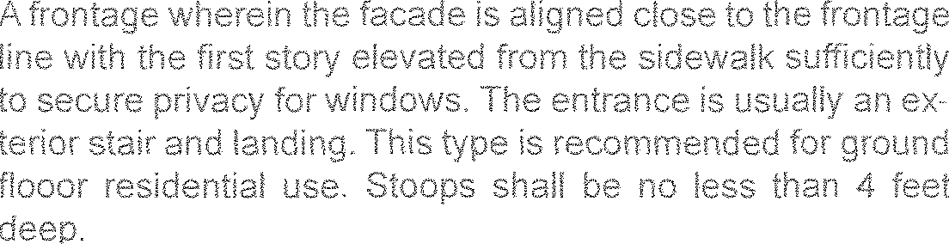

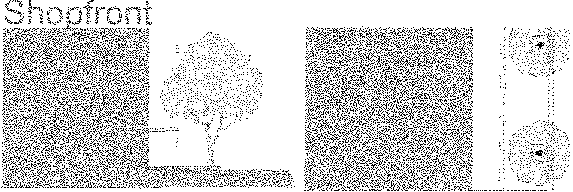 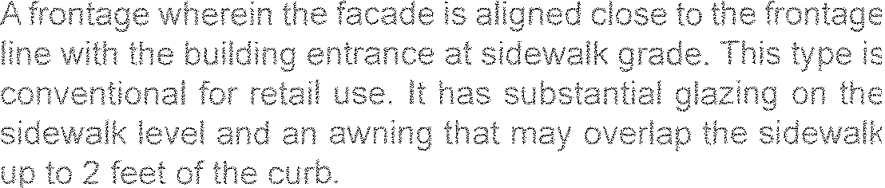

 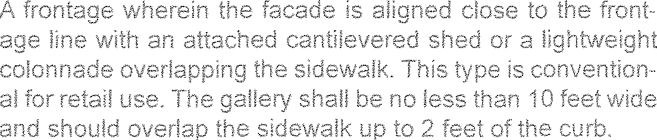

 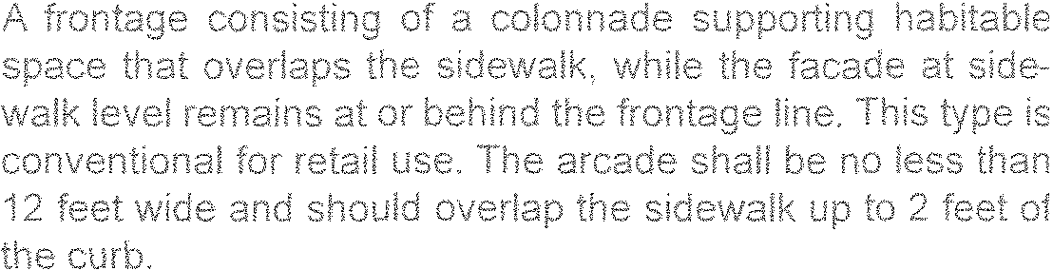

### ARCHITECTURAL STANDARDS

















* 1. NONCONFORMITI ES

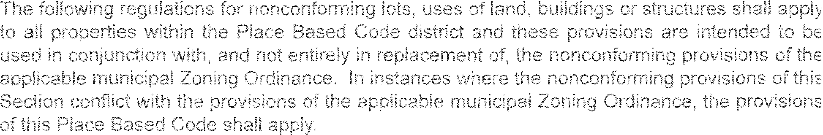

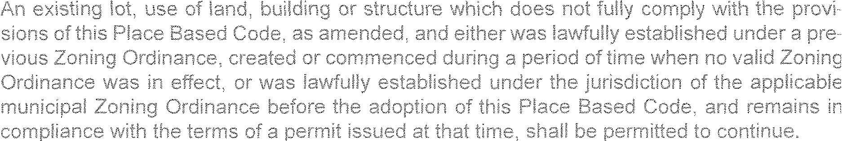

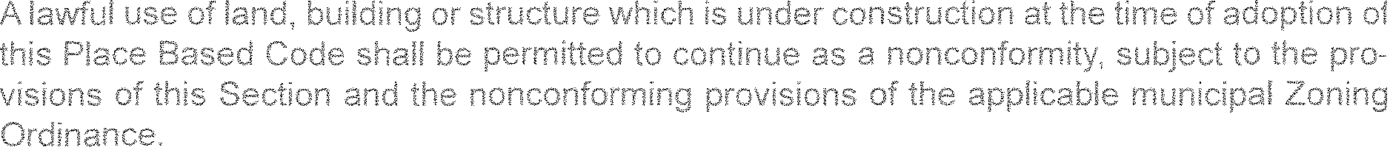











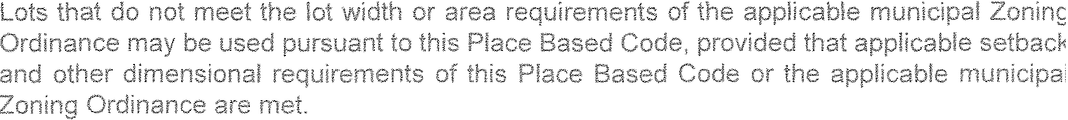

* 1. PARKING AND GARAGES

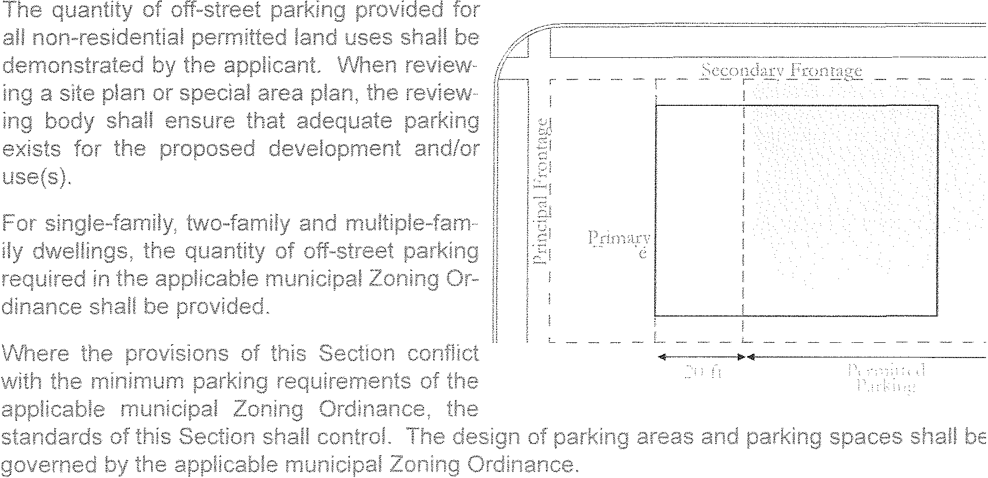















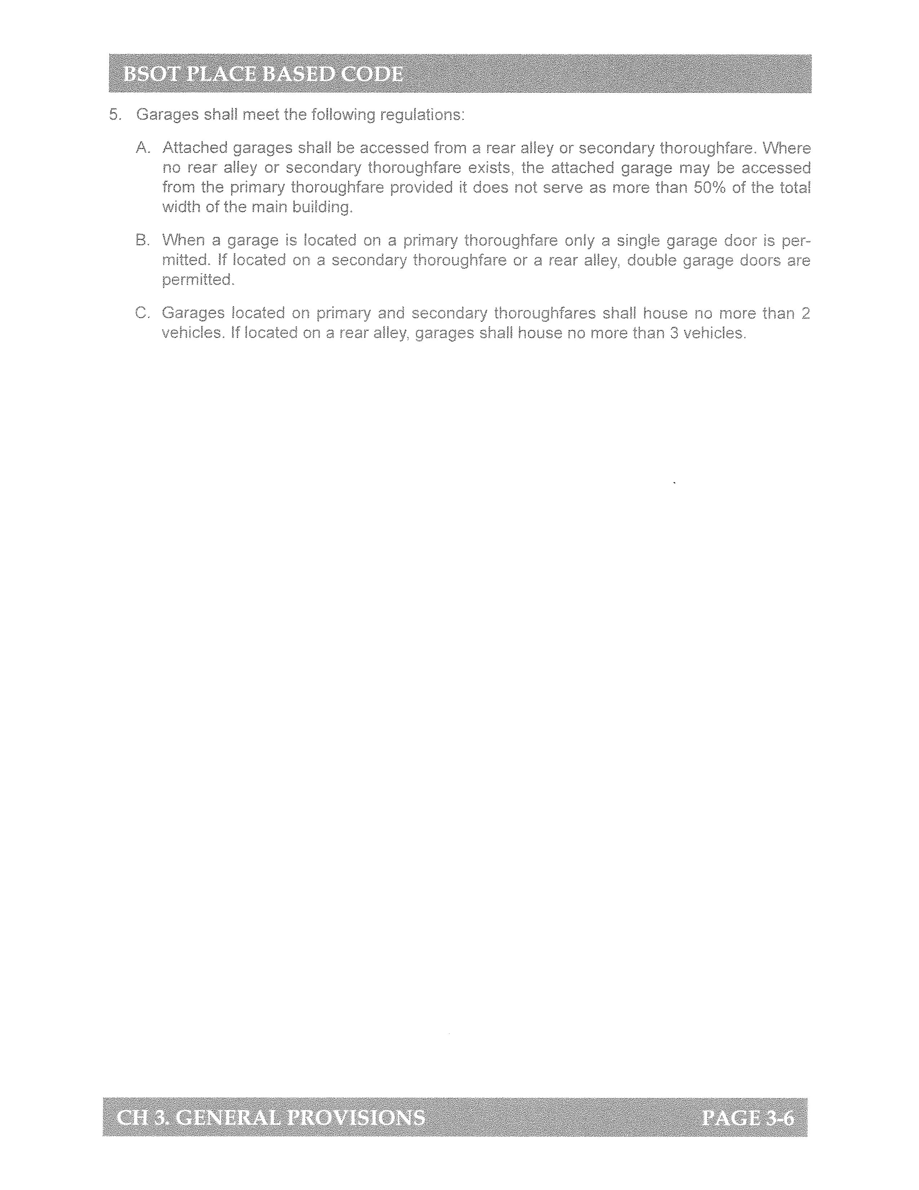

CHAPTER 4. ZONE STANDARDS

* 1. INTENT



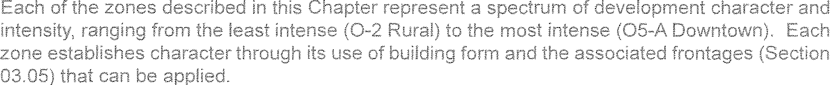



* 1. APPLICABI LITY



* 1. DIMENSIONAL STANDARDS FOR LOTS





Zones Minimum Width

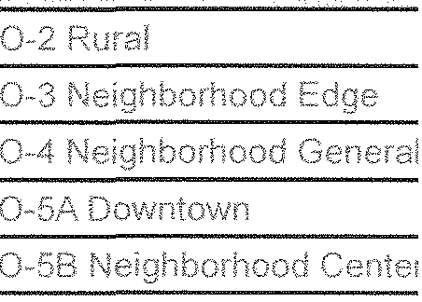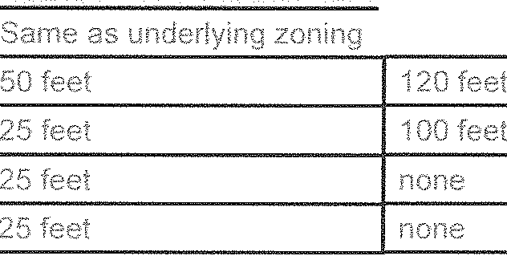

IMaximum Width





 

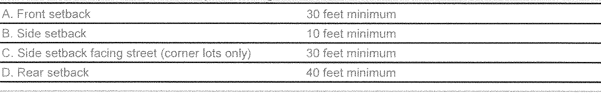

Dimensional Requirements - Principal Building

Street

02 Rural Zone

J_ _

I

(1, C)

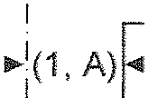

Principal Building Envelope

-- *---,/ '---*

I

"" (i , D) 1"11 Comer

I Lot

I

_ _ L_ _ _ _

Principal Building Dimensional Requirements

..,.1 (1,

I

I 'V

I r "' ' ,·,co ( 1, B)

.... (1,

I

I Interior

Lot

L -<'·_:_-··-·/ - - - - --.£' -·- -

-·- - - .J

 

DimensionalRequirements - Accessory Building

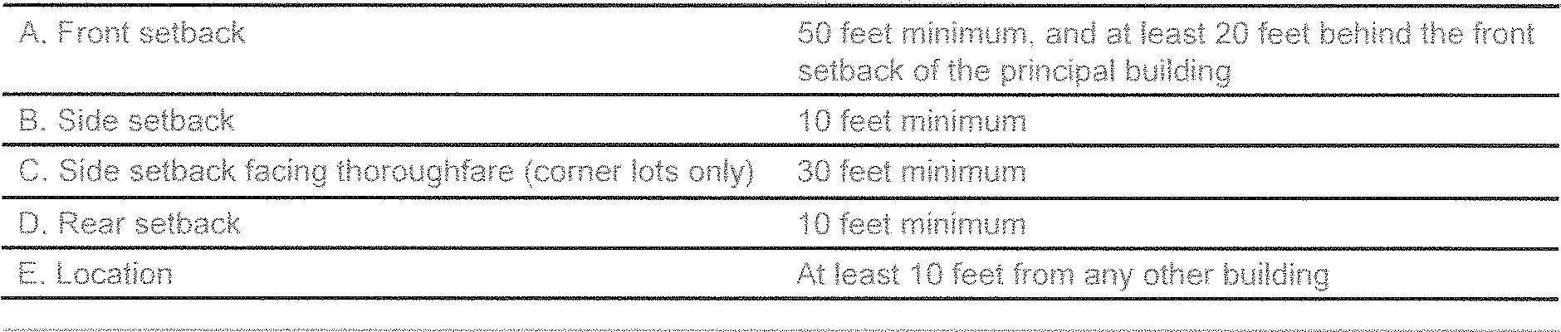

Street 02 Rural Zone

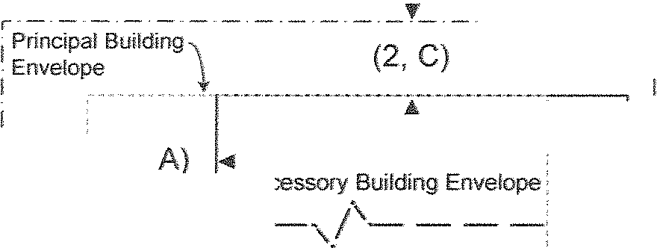

Lot Line

-·-· - -·- - !

f

Accessory Building Dimensional Requirements

.,.: (2,

J _ _ _ _ _

I

(2, D} 1...,

L. _

Corner Lot

I _ _

(2, D}

: 1 Interior

1 Lot

1

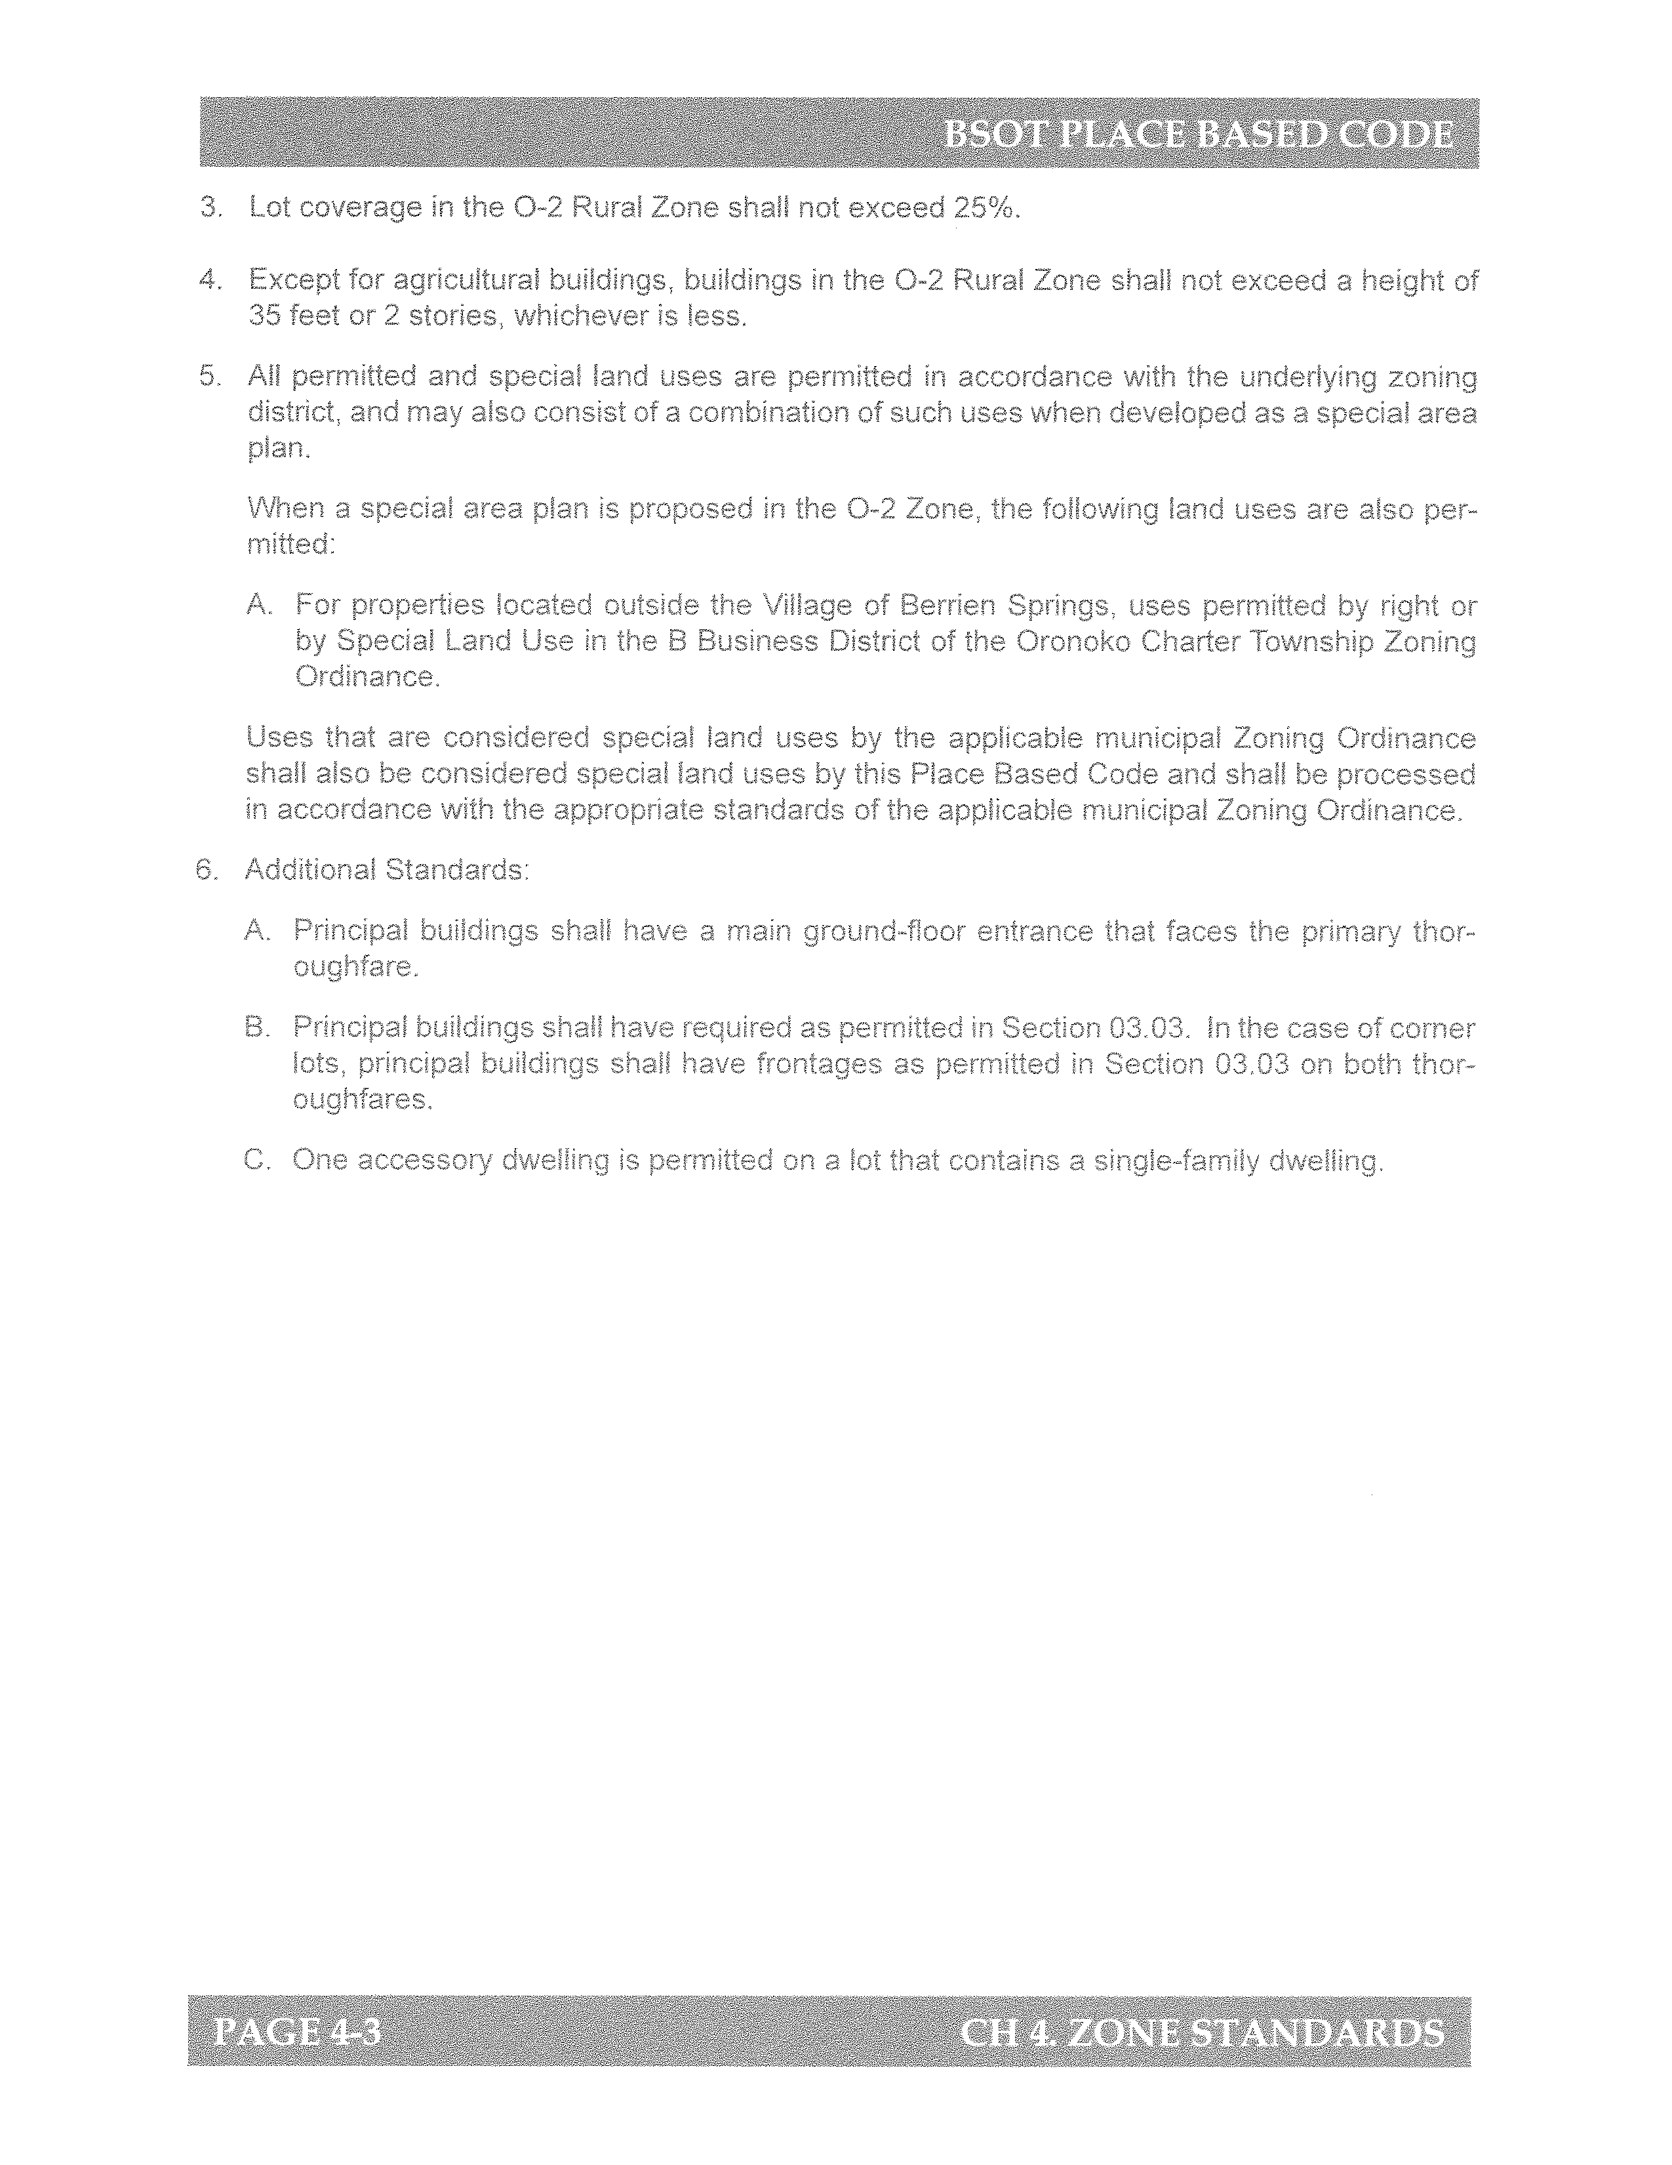



 

Dimensional Requirements - Principal Building

03 Neighborhood Edge Zone .

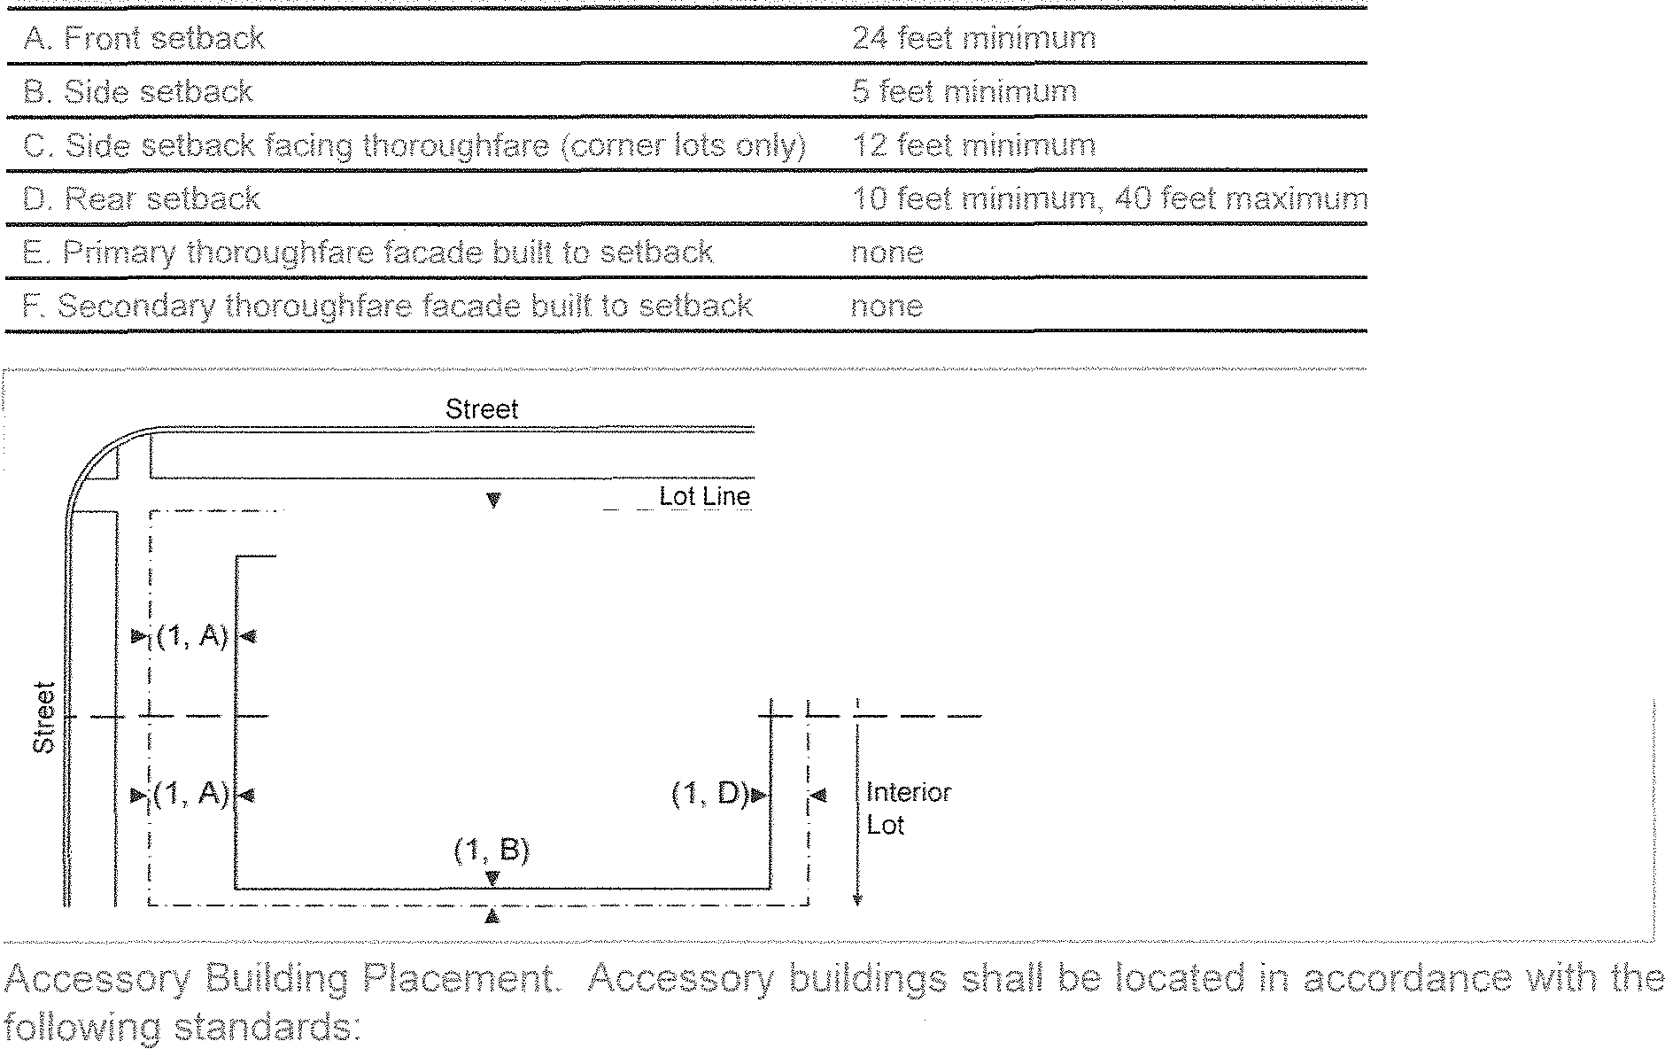

(1, C)

Principal Building , Dimensional Requirements

. . . . (1, 0)111> i..i

P 8

rmc1pal u11dmg Envelope 1

----...,/'-----

Corner Lot

Dimensional Requirements - Accessory Building

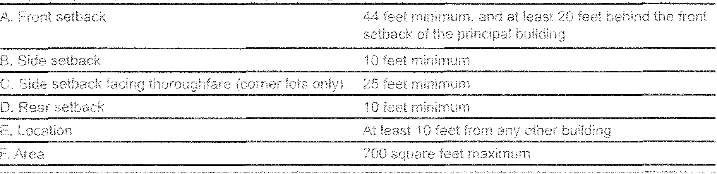

Street 03 Neighborhood Edge Zone .

Accessory Building . Dimensional Requirements ·

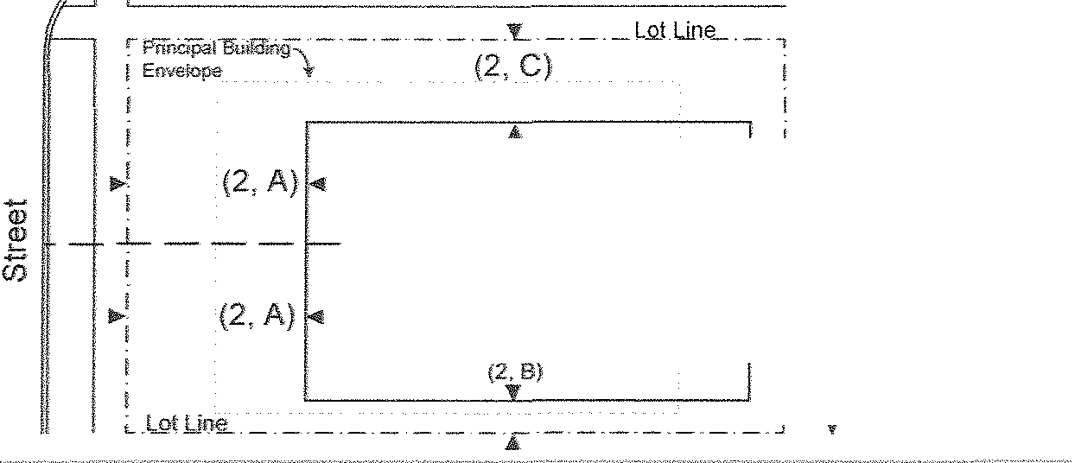

"" Accessory Building Envelope

(2, 1...

I

Corner Lot

--,/'-----

L_ _ _ _

I

(2,D) I 1"' I

Interior Lot

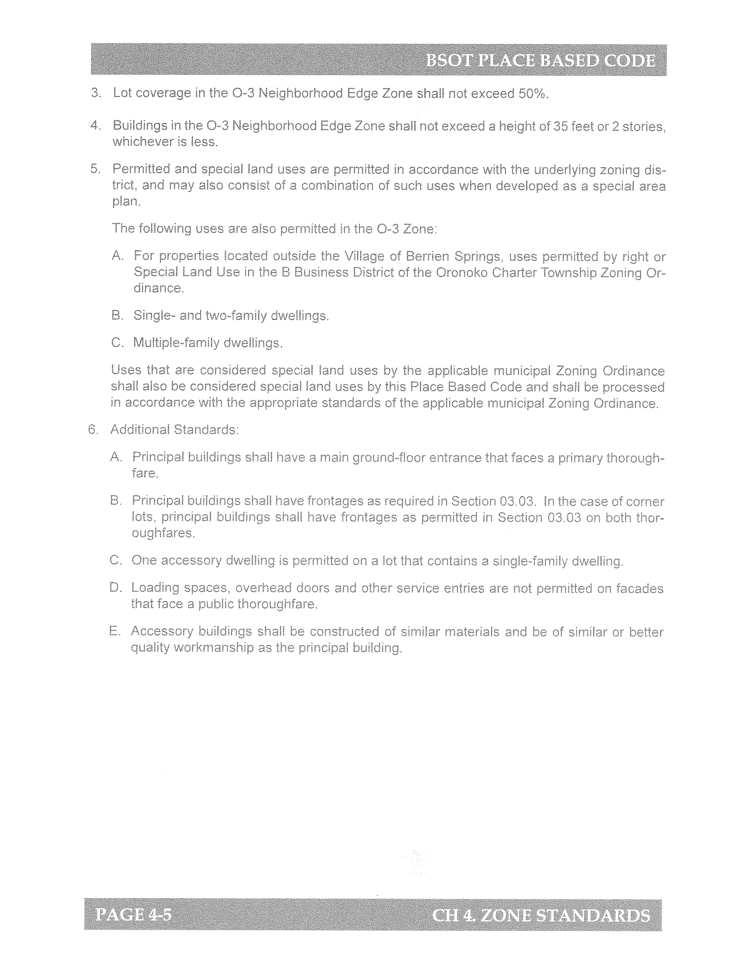





Dimensional Requirements - Principal Building

Lot Line

·- - -- - "l

(1,"C) I<!

r

Corner

Principal Building Dimensional Requirements ·

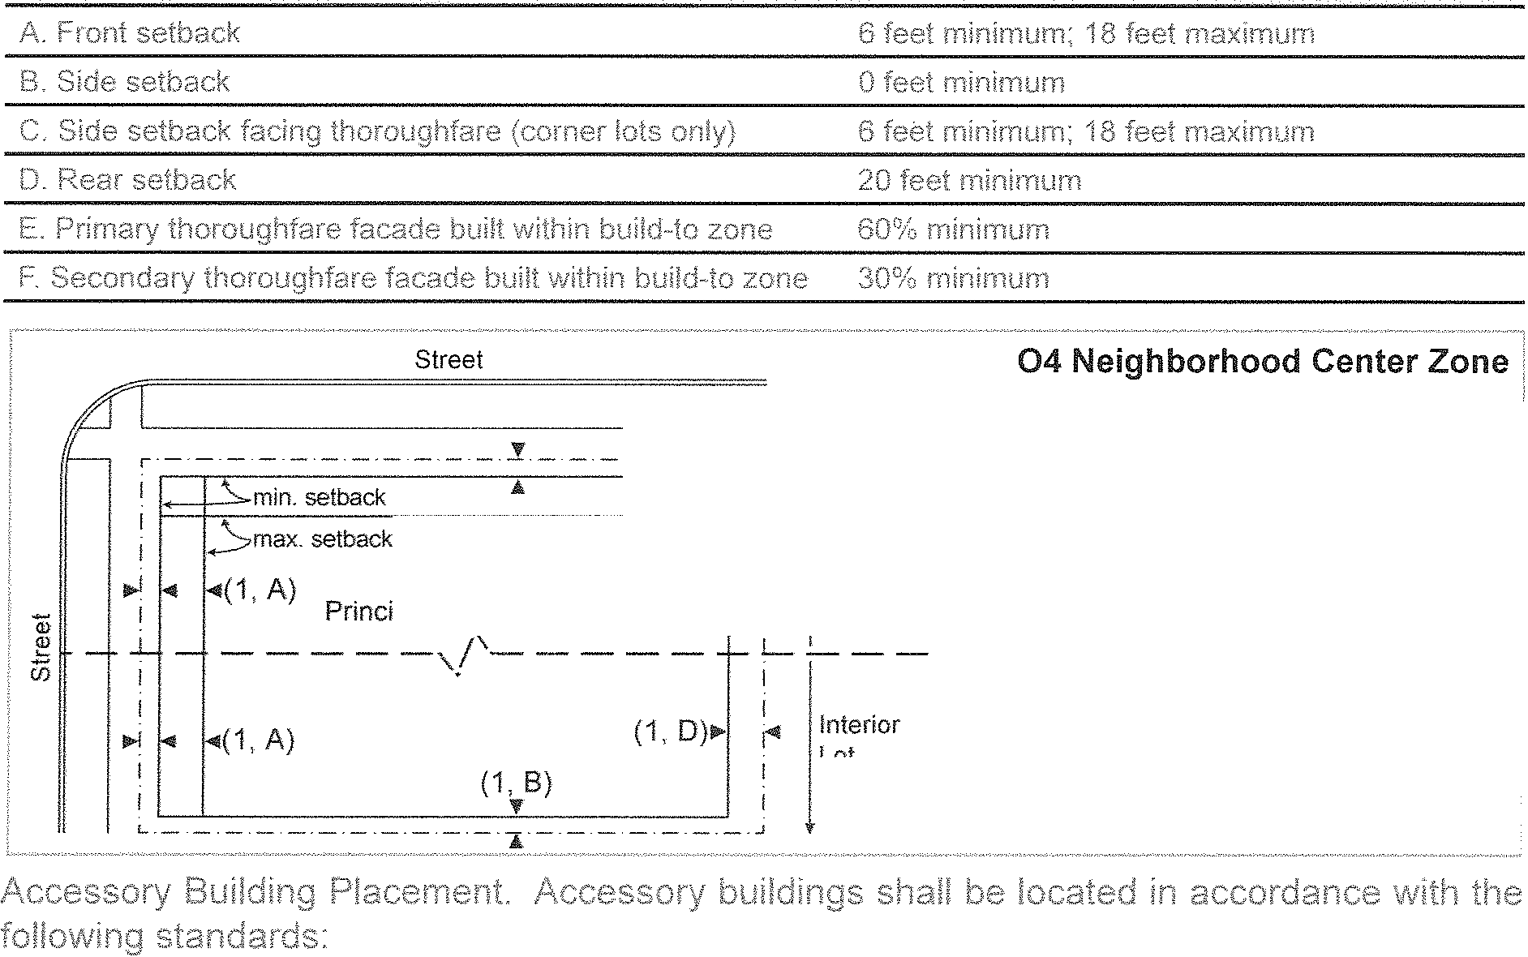

(1, D)

1

I Lot

( ' A) Principal Building Envelope

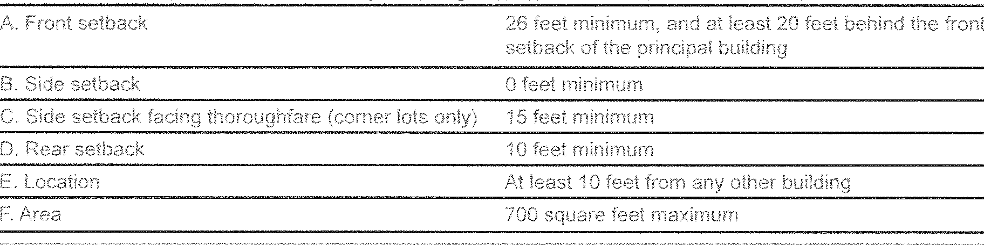

Dimensional Requirements - Accessory Building

Street 04 Neighborhood Center Zone

r - - - - - - - - -·- - -

Building Envelope (2, C)

Lot Line

-·-·- - 1



Accessory Building

Dimensional Requirements

11>! (2, A) (2, O)

1 Accessory Building Envelope

J_, _ ----_ , /'-- ---·

I '-.

I

"'1 (2, A) (2, 0)

(2, B)

I Corner

k Lot

L_ .!_ _

IInterior

1 ILot

i

















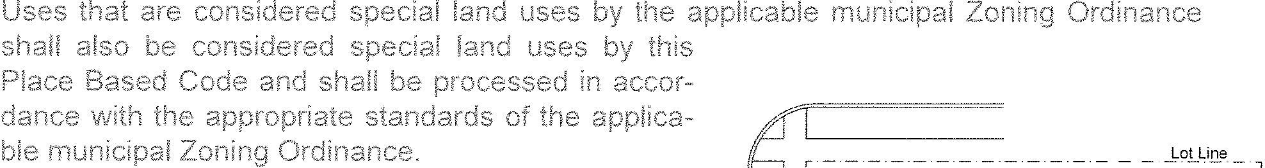

Principal Building

Permitted

Street

Corner

Lot

Street

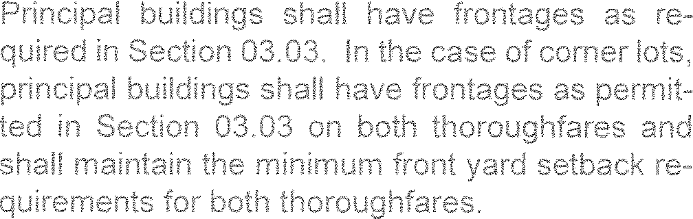

Not Permitted

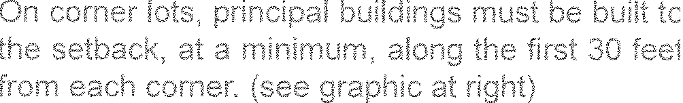

--Lot Line ,

 Corner Lot

Principal Building





### 0-5A DOWNTOWN



 

Dimensional Requirements - Principal Building

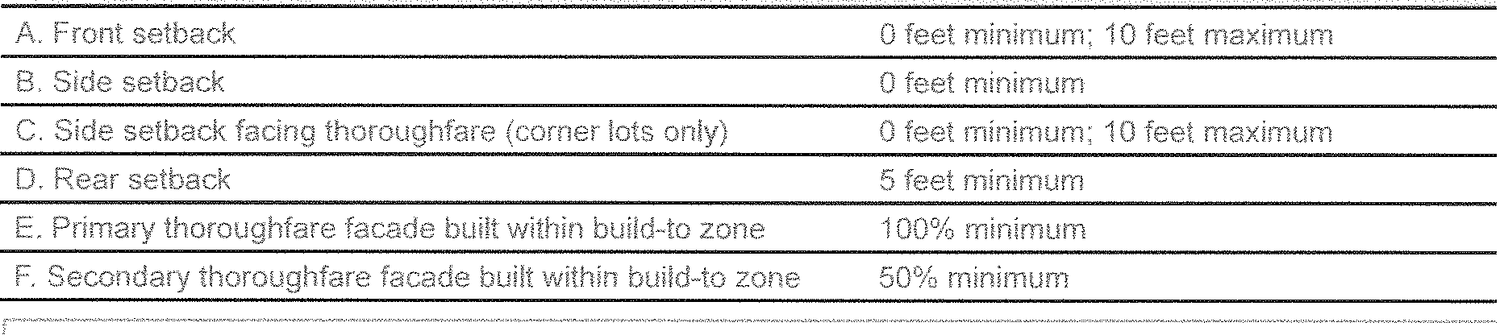

Street 05A Downtown Zone

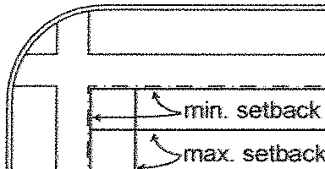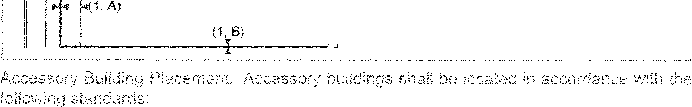

(1, A)

(1, C)

.Lot Line

(1, D) 1-<11 Corner

1 Lot

Principal Building Dimensional Requirements

Principal Building Envelope



(1, D)

Dimensional Requirements - Accessory Building

I

L_ _ _ _

i

1' Interior

I Lot

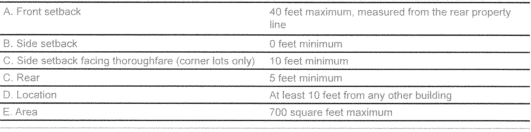

Street 05A Downtown Zone

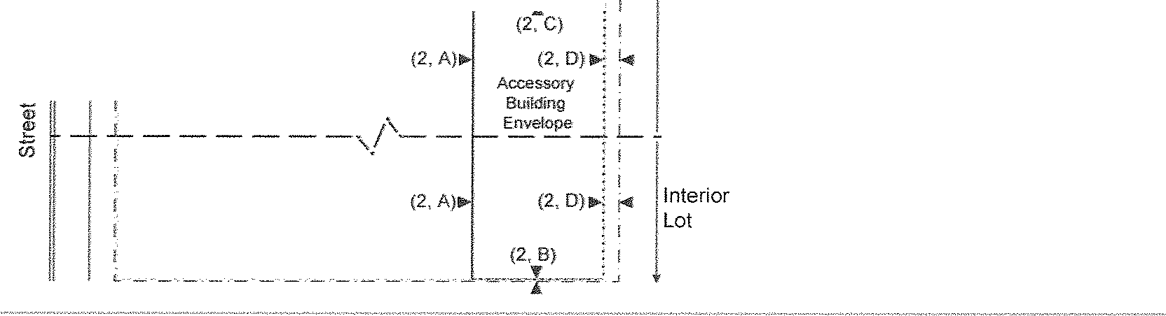

- - - - - - -·- - - -- - - - -

Building Envelope

Accessory Building Dimensional Requirements

Corner

Lot











Street





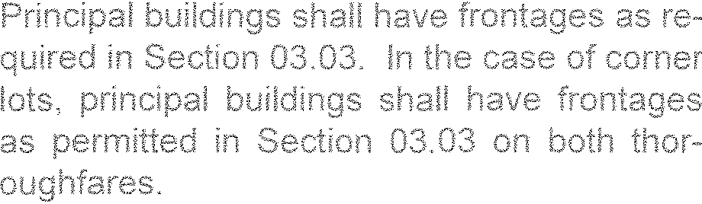

Street



Permitted

-- -·--Lot Li-ne--·,

Principal Building

Corner Lot

Not Permitted

_ -o!J-i!J!' _

Principal Building

Corner Lot

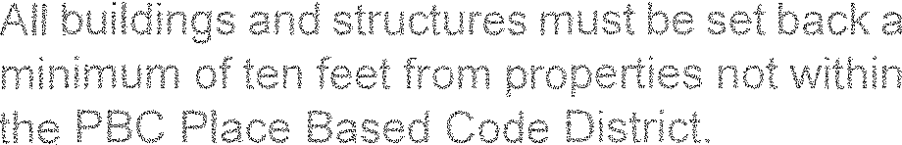



### 0-58 NEIGHBORHOOD CENTER ZONE



 

Dimensional Requirements - Principal Building

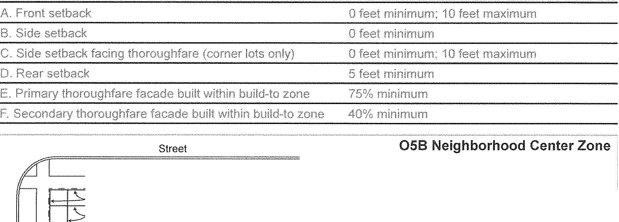

_ _ _ _ _ _ :f _ _ _ _1.ot U;ie _ ,

min. setback " i

Principal Building

Dimensional Requirements

&

max. setback (1, C)

(i, D)

(1, A)

1..i Corner

I Lot

*-----,/ '--- --*

(1, D)

Principal Building Envelope

I

L_ _ _ _

I

i""'

I

Interior

Lot

(1, 8)



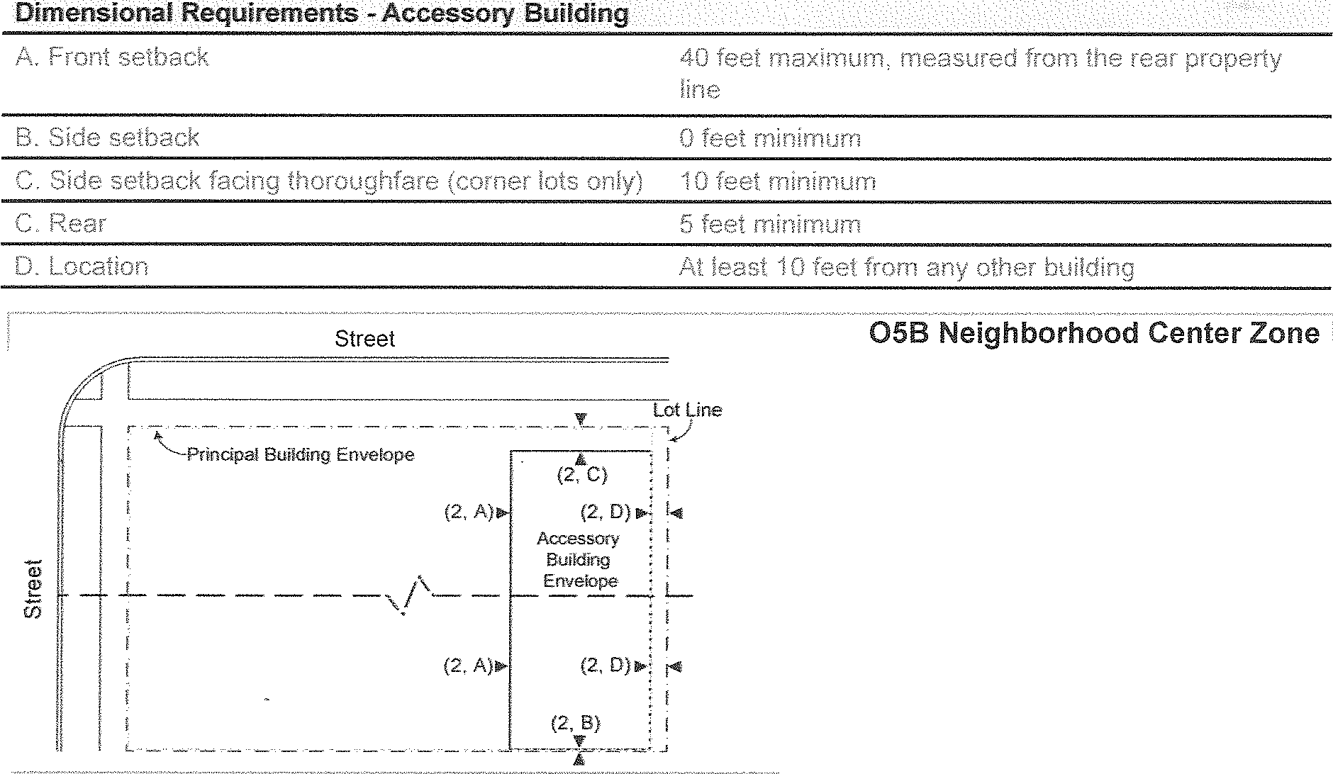

I

i

Corner

I

I Lot

I I

......;. L_ _ _ _

I

I

Interior Lot

Accessory Building Dimensional Requirements



















Street



Permitted

Lot Line

- --

-·-·-·-,

Principal Building

Corner Lot



Street



Not Permitted

Corner Lot



Principal Building



CHAPTER S. THOROUGHFARES

* 1. INTENT

The purpose of this Chapter is to identify the street types permitted within each Zone of this Place Based Code. It is further the intent of this Chapter to regulate the size, lane widths, parking provi­ sions, and design speeds for new thoroughfares proposed as part of a special area plan, or other development that is pursuant to the provisions of this Place Based Code.

## APPLICABILITY

The regulations of this Chapter apply to all new thoroughfares proposed pursuant to the provi­ sions of this Place Based Code. Existing or proposed roadways that are or are proposed to be under the jurisdiction of the Berrien County Road Commission, Michigan Department of Transpor­ tation, or Village of Berrien Springs are not required to comply with the provisions of this Chapter, although when existing streets are reconstructed, redesigned or otherwise altered, compliance is desired and encouraged. Where the provisions of this Chapter conflict with an applicable munic­ ipal Private Road Ordinance, the standards of this chapter shall control.

## DESIGN STANDARDS APPLICABLE TOAl THOROUGHFARE TYPES

1. All thoroughfares, including ail elements with the thoroughfare such as sidewalks, planter strips and curbs, must be approved by the Berrien Springs/Oronoko Fire Department (BSOFD) and other applicable reviewing agency prior to construction. All thoroughfares shall meet the following minimum design standards, along with any others imposed by any applicable re­ viewing agency and the Township or Village Engineer:



Minimum travel width 20 feet Minimum clearance height 13.5 feet

Lane width 10 feet minimum /11 or 13 feet maximum

Parking lanes 1 per required per thoroughfare (minimum), except for alleys and roads, as defined and regulated in this Place Based Code

Parking lane width (parallel) 8 feet minimum width Parking lane width (diagonal) 18 feet minimum width

Planters Required on both sides of all thoroughfares Planter width (continuous) Continuous planter strips must be at least 7' wide Planter width (tree wells) Tree wells must be at least 5'x5'

Sidewalks 5' minimum sidewalk required on both sides of all new thoroughfares except for alleys and roads, as defined and regulated in this Place Based Code

1. Curb radii directly impact vehicle turning speeds and pedestrian crossing distances. Minimiz­ ing the size of a corner radius is critical to creating compact intersections with safe turning speeds while allowing adequate access for emergency vehicles. This BSOT Place-Based Code does not specify minimum curb radii. However, curb radii on all intersections between new thoroughfares or between new and existing thoroughfares shall be designed to minimize vehicular speeds, minimize pedestrian crossing distances, and preserve and protect the gen­ eral health, safety and welfare of the community.

Curb radii on all proposed thoroughfares are subject to review by the applicable reviewing body, TownshipNillage Engineer, the BSOFD and other applicable agencies during the site plan review process pursuant to Section 02.01 of this Place-Based Code.

1. The Zoning Administrator may, upon request, allow for the deferral of the construction of sidewalks and/or walkways required by this Place-Based Code until some future date, pro­ vided that the area containing the sidewalks and/or walkways remains unused until they are constructed in accordance with this Section.
2. Thoroughfares proposed pursuant to this chapter shall be subject to Site Plan Review as oulined in Section 02.01 of this Place Based Code and shall also be reviewed by a registered Professional Engineer. The Zoning Administrator may require the submission of additional materials, including information pertaining to constuction materials and signed road mainte­ nance agreements along with other items required for site plan submittal.
3. When public roads are proposed or developed pursuant to the standards of the Berrien Coun­ ty Road Commission, the following standards shall apply:
   1. A public access easement shall be provided that is at least 14 feet in width that includes a sidewalk at least 7 feet wide.
   2. The easement required in subsection 1 above shall meet the standards of Section 03.02 of this Place Based Code pertaining to streetscapes.

### PREFERRED THOROUGHFARE TYPES

The following Thoroughfare types are specified and regulated in this Chapter. Applicants are encouraged to utilize the thoroughfare designs contained in the following sections, though it is not required. In all cases, thoroughfares shall meet the minimum standards of Section 05.03, the BSOFD and any other applicable reviewing agencies.



|  |  |  |  |
| --- | --- | --- | --- |
| Rear Alley | RA |  | 05.05  05.06  05.07 |
| Road | RD |  |
| Street | ST |  |
| Commercial Street cs 05.08 | | | |
| Frontage Street | FS |  | 05.09 |
| Boulevard | RA |  | 05.10 |

### REAR ALLEYS



Zones Permitted All Zones

Right-of-way *I* easement width 20 feet

Pavement Width 20 feet

Design Speed 10 mph

Traffic Lanes None required

Parking Lanes None permitted

Walkway Type None required

Planter Type None required

Curb Type Inverted Crown

Landscag_e Type

### 05.68 ROADS

None required

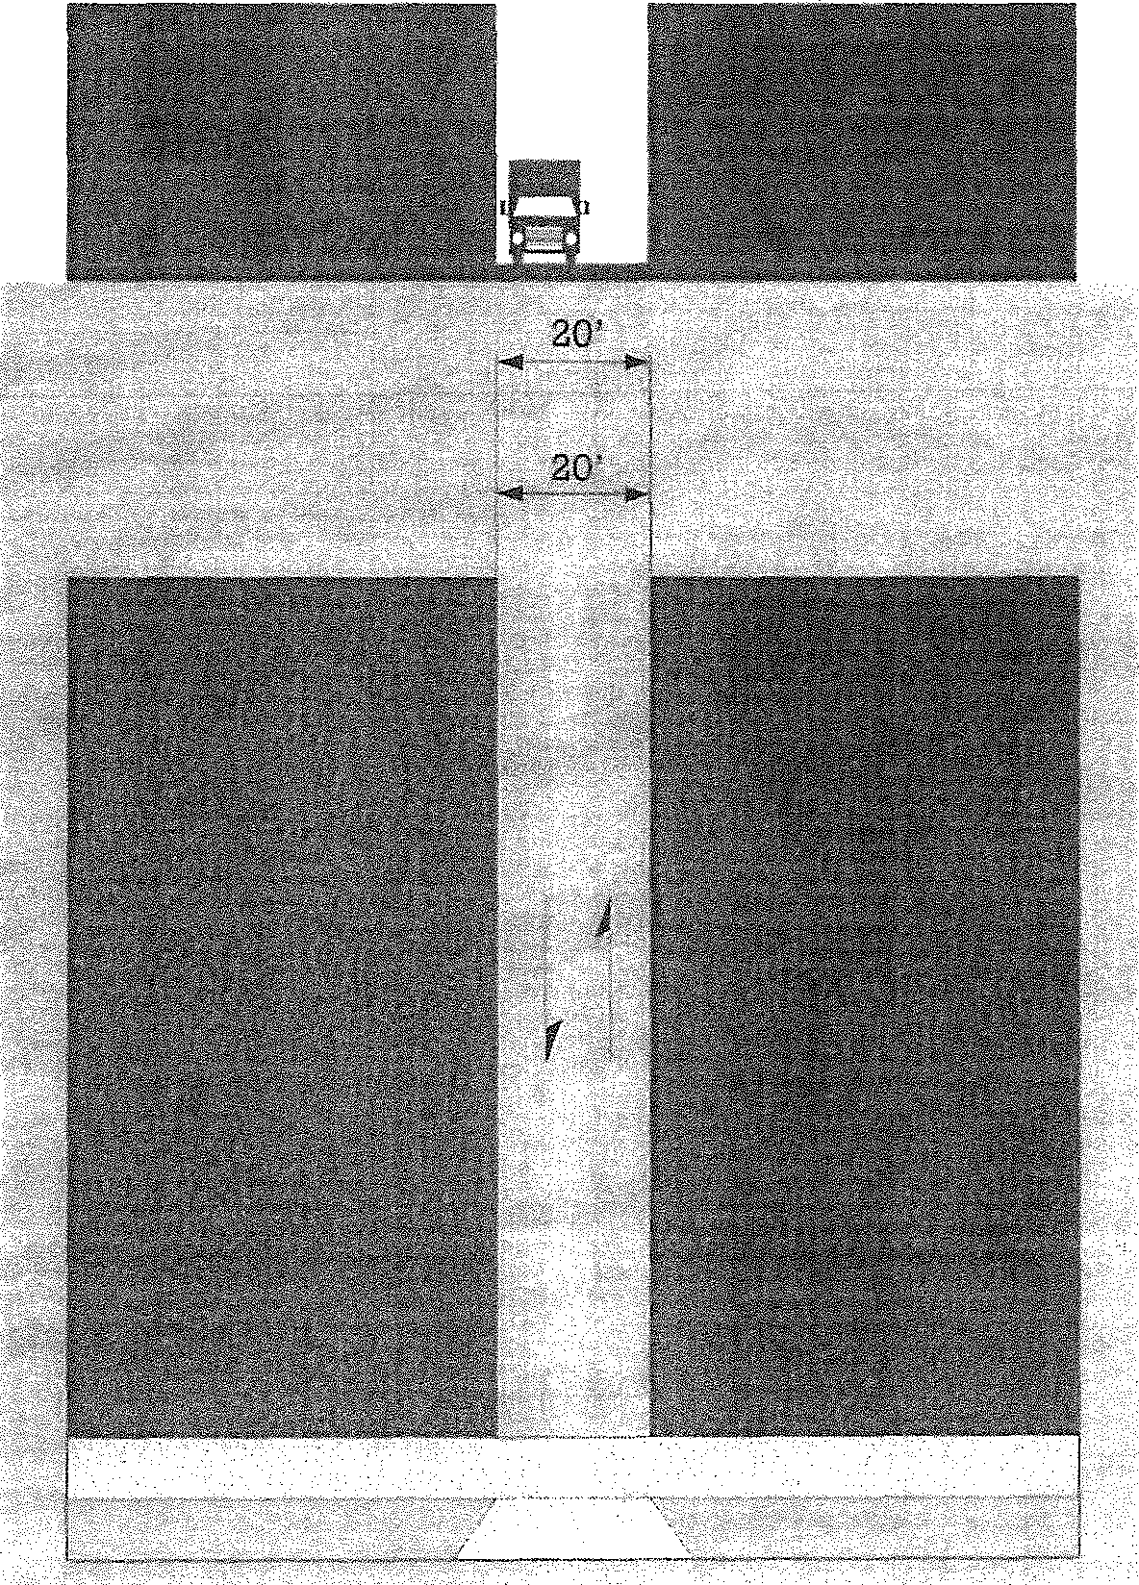



Zones Permitted 0-2, 0-3

Right-of-way *I* easement width 42 feet

Pavement Width 22 feet

Design Speed 30 mph

Traffic Lanes 2 total

Parking Lanes None permitted

Planter Type None required

Curb Type Inverted Crown

Landscape Type None required

### STREETS

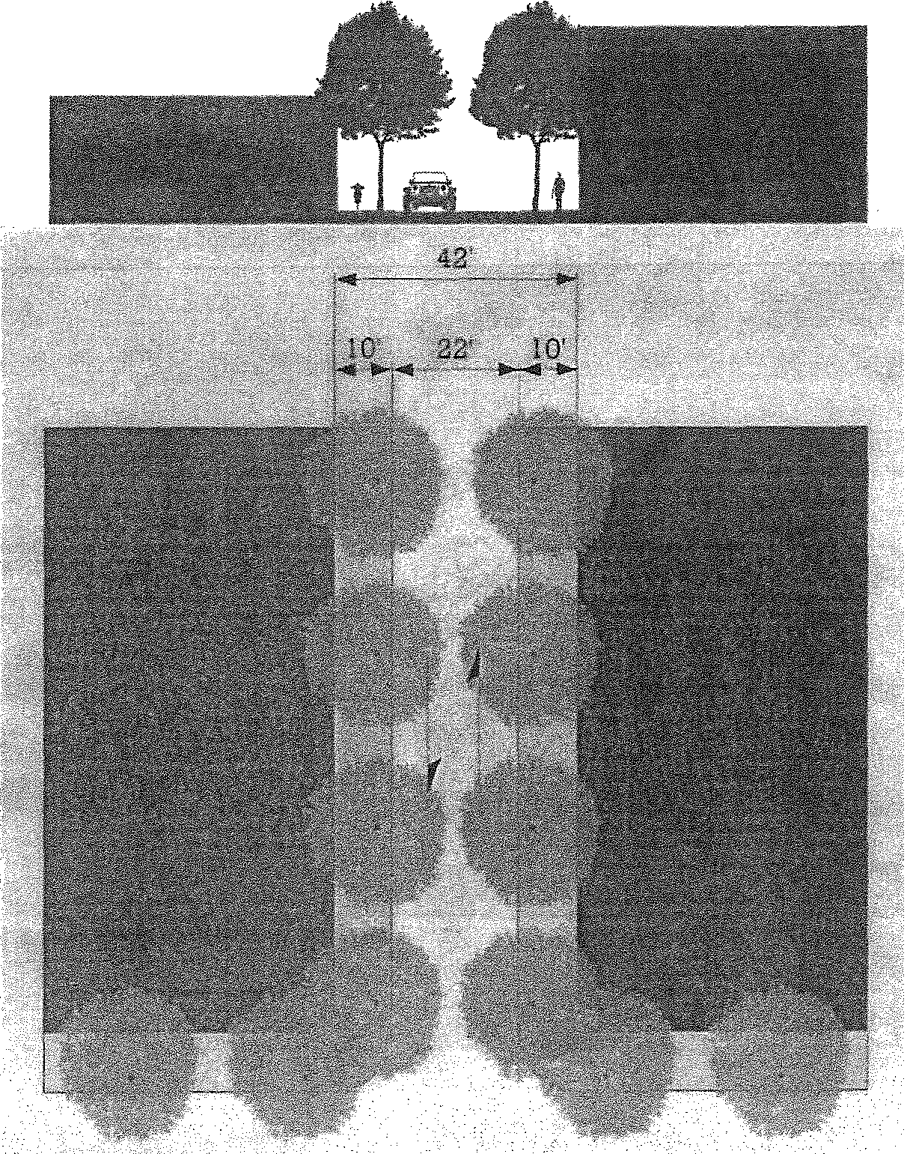

ST,.54-30

Zones Permitted All zones

Right-of-way *I* easement width 54 feet

Pavement Width 30 feet

Design Speed 20 mph

Traffic Lanes 2 total

Parking Lane Permitted on one side, un­ marked, 8 feet from curb

Walkway Type 5' wide (or wider) sidewalk

Planter Type 7' continuous planter strip or 5'x5' tree wells

Curb Type Curb

Landscape Type Trees, evenly spaced 30' apart

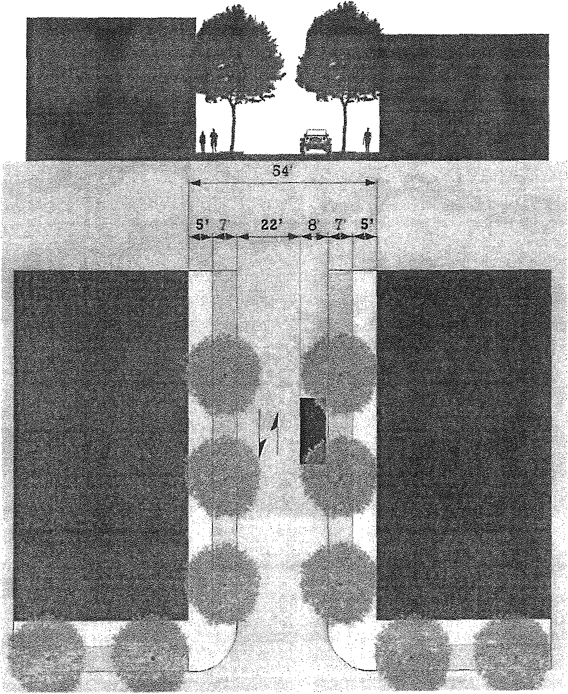



Zones Permitted 0-3, 0-4

Right-of-way *I* easement width 62 feet

Pavement Width 38 feet

Design Speed 20 mph

Traffic Lanes 2 total

Parking Lanes Permitted on each side, 8 feet from curb

Walkway Type 5' wide (or wider) sidewalk

Planter Type *T* continuous planter strip or 5'x5' tree wells

Curb Type Curb

Landscape Type Trees, evenly spaced 30' apart

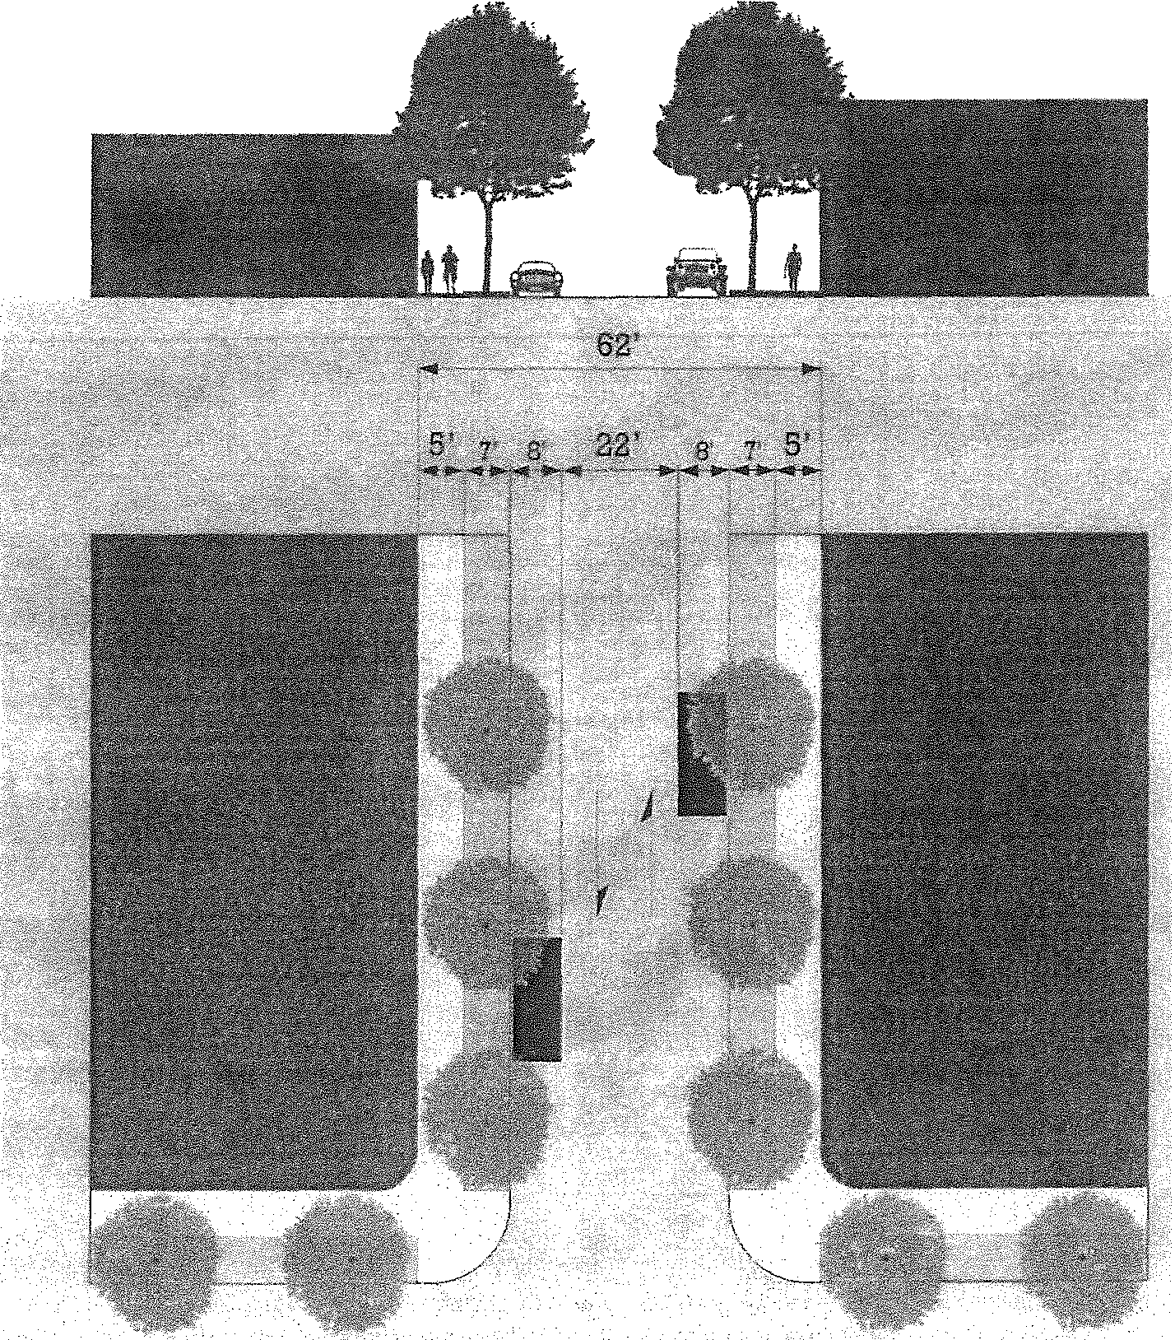

### COMMERCIAL STREET



Zones Permitted 0-5A, 0-58

Right-of-way *I* easement width 76 feet

Pavement Width 38 feet

Design Speed 25 mph

Traffic Lanes 2 total

Parking Lanes Permitted on each side, 8 feet from curb

Walkway Type 19' wide (or wider) sidewalk

Planter Type 5'x5' tree wells

Curb Type Curb

Landscape Type Trees, evenly spaced 30' apart

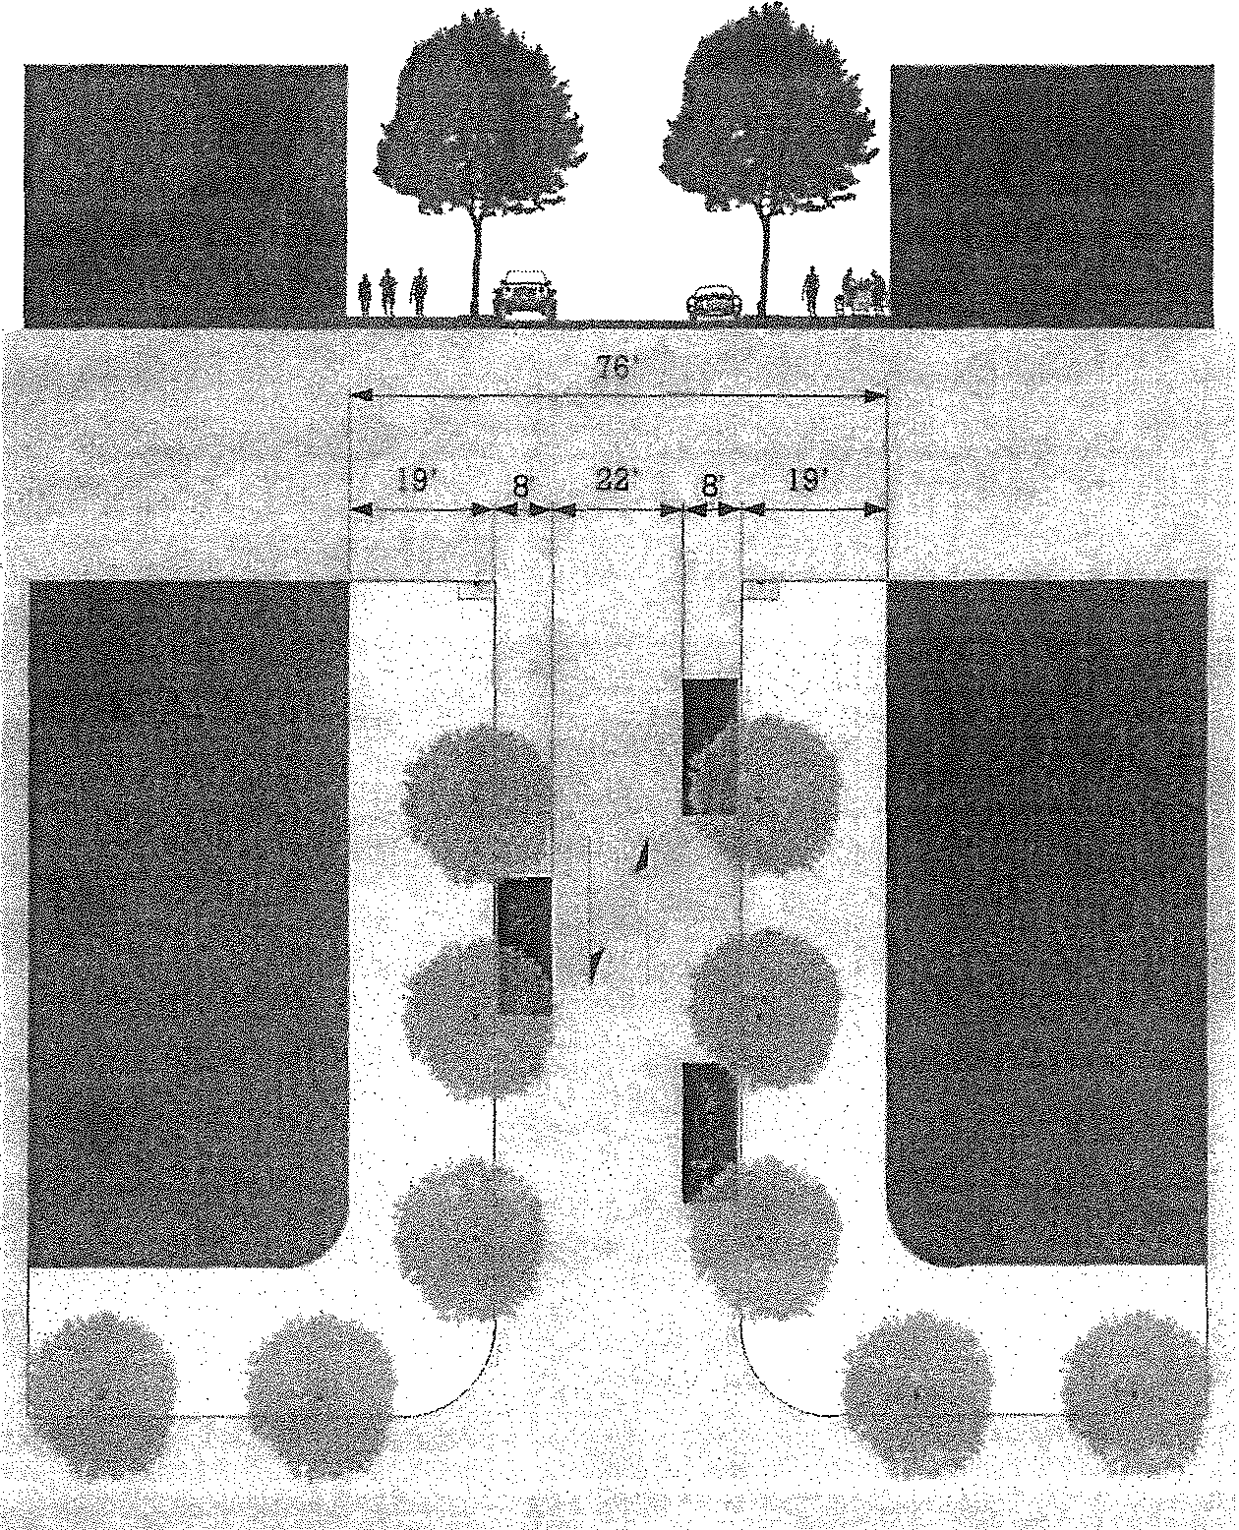



Zones Permitted 0-5A, 0-58

Right-of-way *I* easement width 96 feet

Pavement Width 58 feet

Design Speed 25 mph

Traffic Lanes 2 total

Parking Lanes Permitted on each side, angled at 18 feet

Walkway Type 19' wide (or wider) sidewalk

Planter Type 5'x5' tree wells

Curb Type Curb

Landscape Type Trees, evenly spaced 30' apart

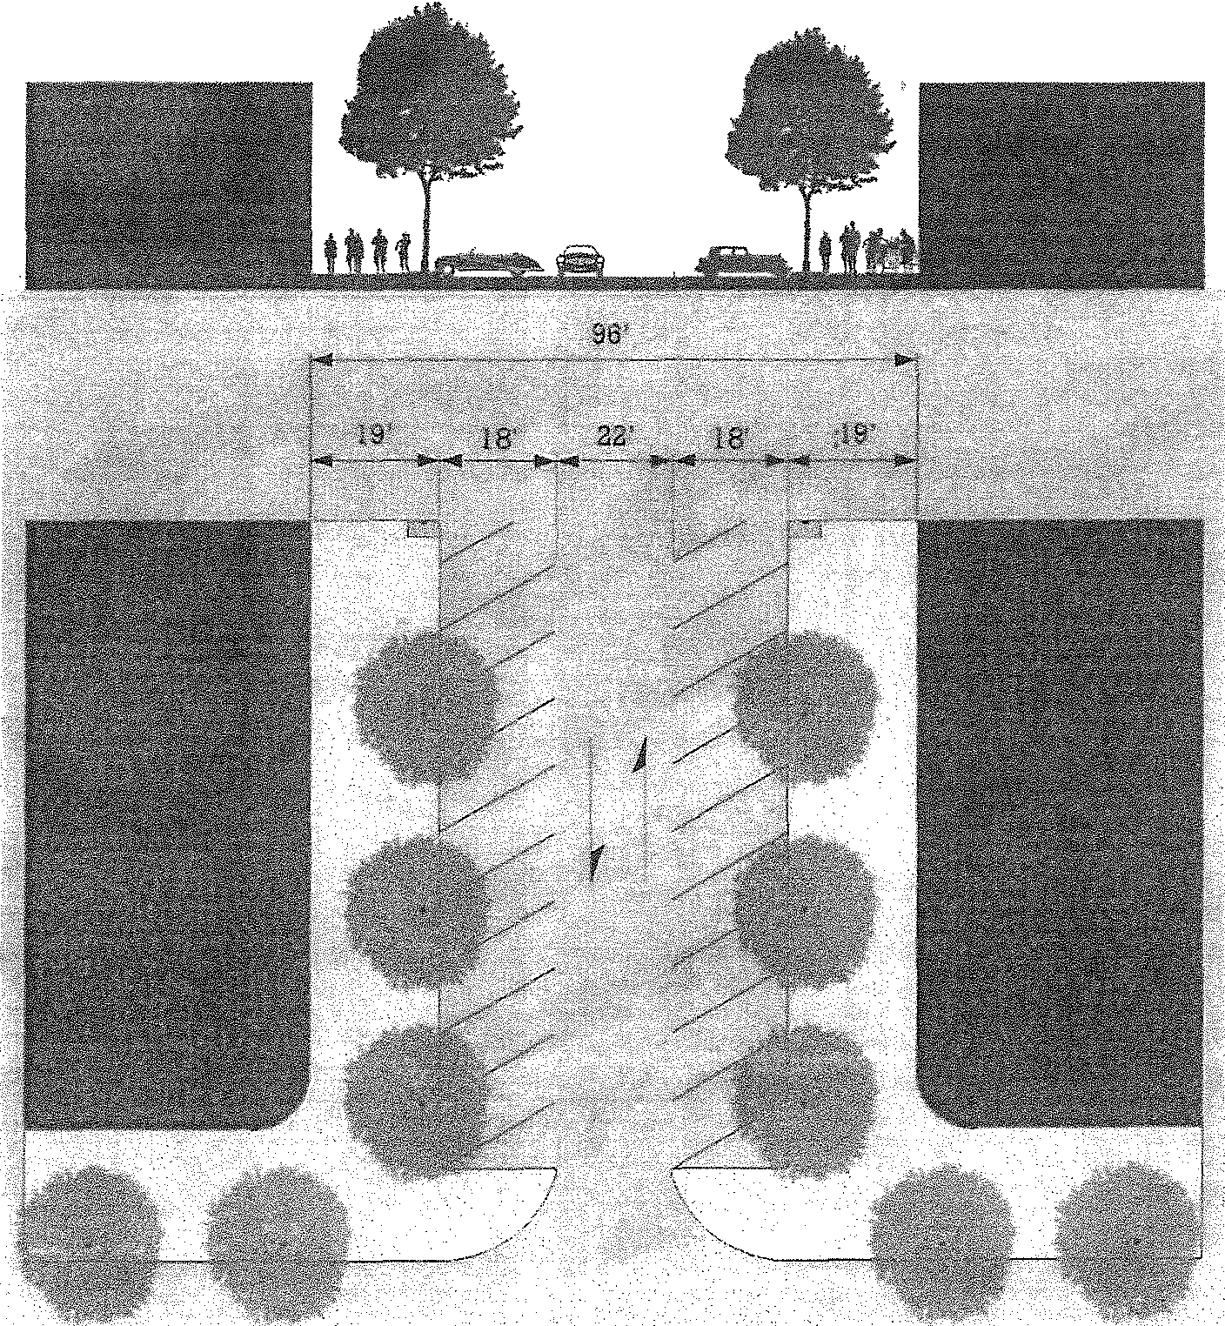

### FRONTAGE STREET

Zones Permitted

FS:'-120-60

0-5A, 0-58

Right-of-way *I* easement width 120 feet

Pavement Width 60 feet

Design Speed 35 mph

Traffic Lanes 4 total (Two two-way slip roads, not including center road)

Parking Lanes Permitted on each side, parallel at

8 feet

Walkway Type 11' wide (or wider) sidewalk

Planter Type 9' continuous planter strip or 5'x5'

tree wells

Curb Type Curb

Landscape Type Trees, evenly spaced 30' apart

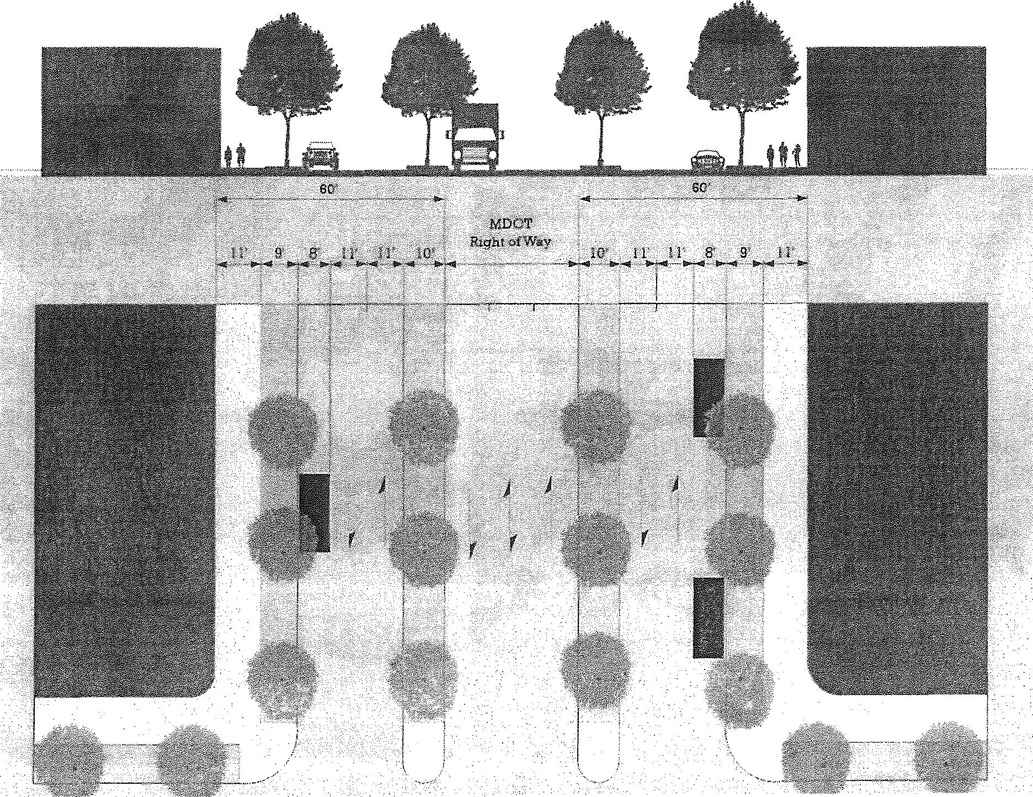

### BOULEVARDS



Zones Permitted 0-5A, 0-58

Right-of-way *I* easement width 88 feet

Pavement Width 38 feet

Design Speed 30 mph

Traffic Lanes 2 (4 total)

Parking Lanes Permitted on each side, parallel at 8 feet or angled at 18 feet

Walkway Type 11' wide (or wider) sidewalk

Planter Type 9' continuous planter strip or 5'x5' tree wells

Curb Type Curb

Landscape Type Trees, evenly spaced 30' apart

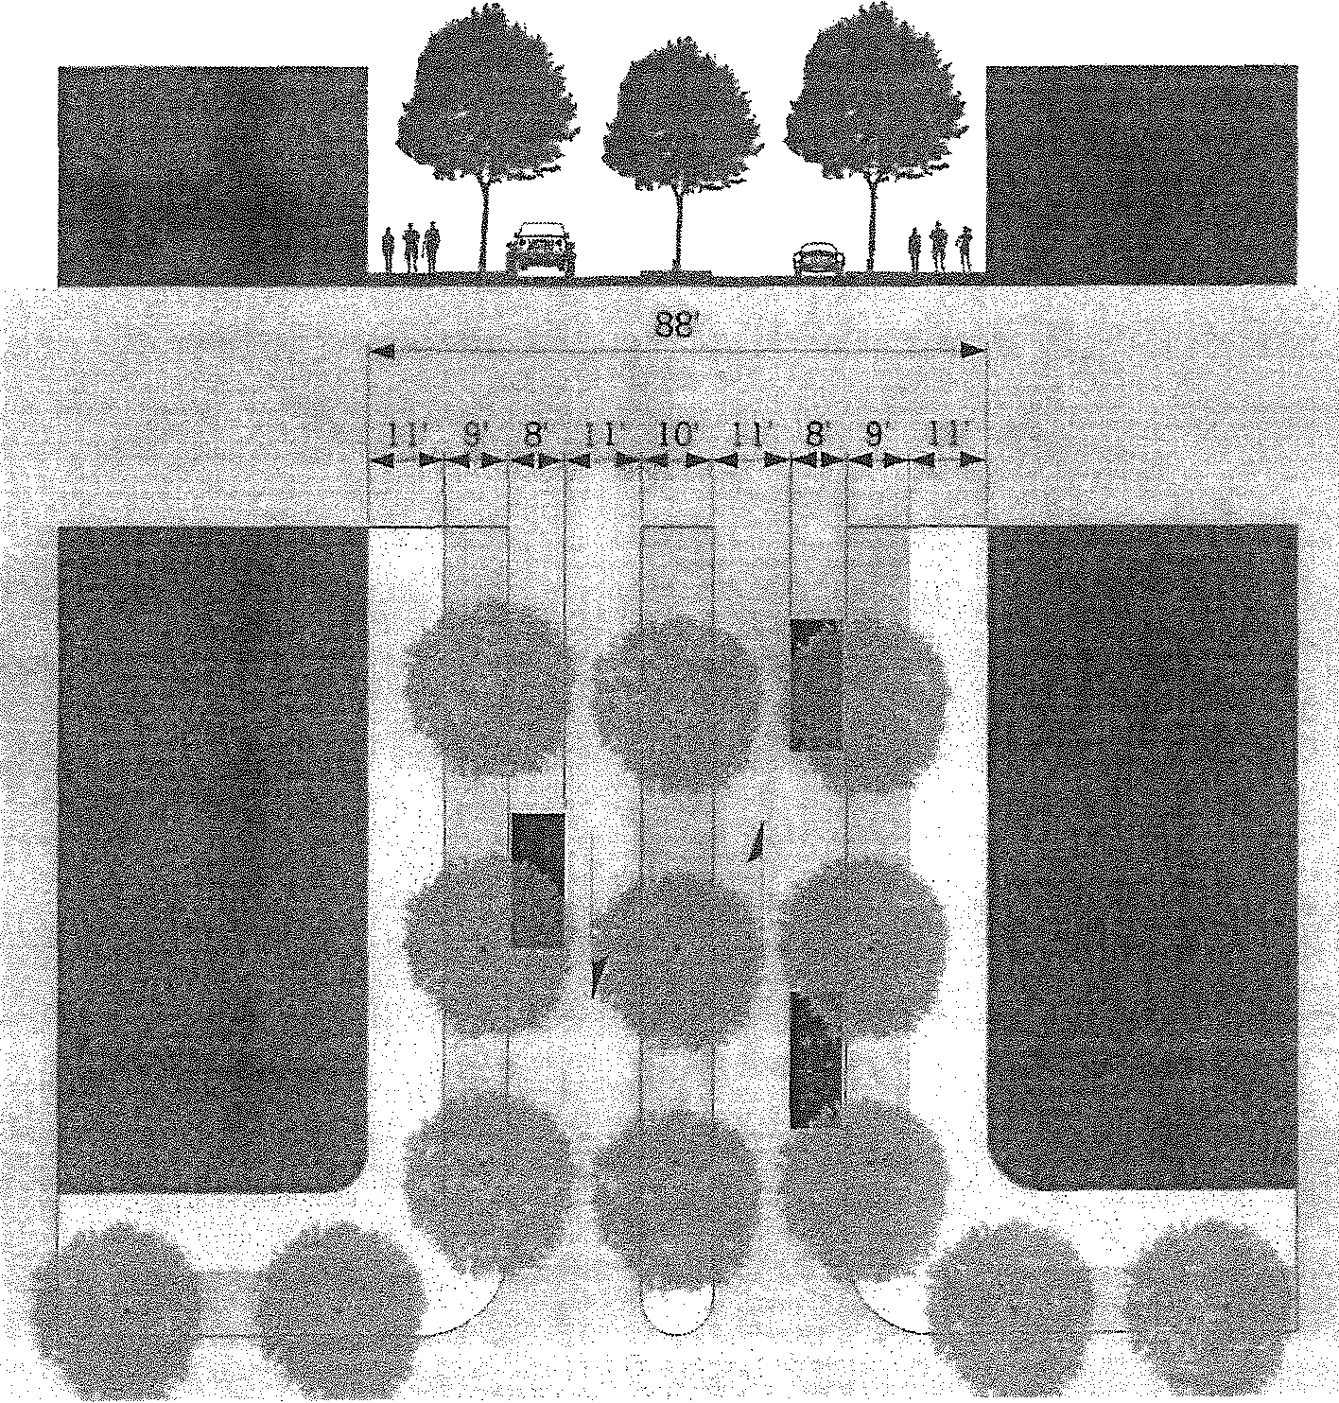

BV-140-iO

Zones Permitted 0-5A, 0-58

Right-of-way *I* easement width 140 feet

Pavement Width 70 feet

Design Speed 35 mph

Traffic Lanes Two two-way slip roads (4 total, not in­ cluding center road)

Parking Lanes Permitted on each side, angled at 18 feet

Walkway Type 11' wide (or wider) sidewalk

Planter Type 9' continuous planter strip or 5'x5' tree wells

Curb Type Curb

Landscape Type Trees, evenly spaced 30' apart

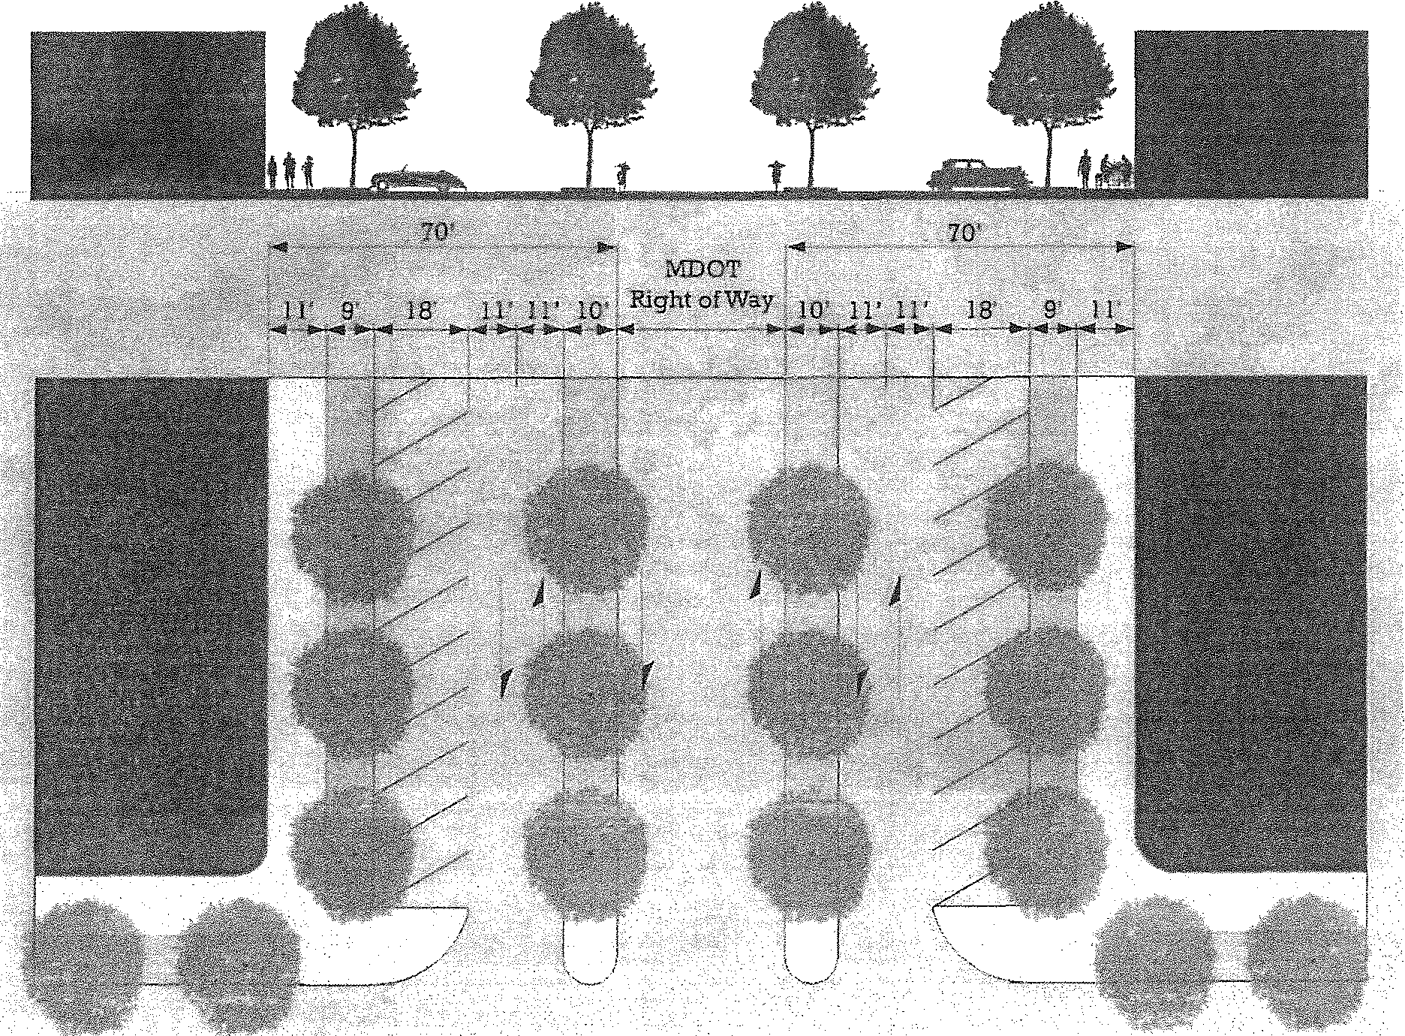

### CHAPTER 6 SIGNS

* 1. PURPOSE

This Chapter sets forth sign standards that are intended to appropriately regulate the placement, type, size, construction, illumination, and number of signs allowed within the Place Based Code zoning district and to require the proper maintenance of signs. The regulations and standards of this Chapter are intended to be content neutral and are considered the minimum necessary to achieve a substantial government interest for public safety, aesthetics, and protection of property values. The purpose of the requirements of this Chapter is to:

1. Protect the public right to receive messages and information protected by the First Amend­ ment of the U.S. Constitution;
2. Safeguard and protect the public health, safety, and general welfare;
3. Promote aesthetic and environmental values of the community by providing for signs that do not impair the attractiveness of the community as a place to live, work and shop;
4. Avoid traffic safety hazards to motorists, bicyclists, and pedestrians, caused by visual distrac­ tions and obstructions;
5. Enable the public to locate goods, services and facilities without excessive difficulty and con­ fusion by restricting the number and placement of signs;
6. Provide for signs as an effective channel of communication, while ensuring that signs are aesthetically designed and proportioned in relation to adjacent structures and the structures to which they are attached;
7. Recognize that the principal intent of commercial signs is for identification of an establishment on the premises, and not for advertising off-premises activities; and
8. Regulate portable commercial signs in recognition of their significant negative impact on traf- fic safety and aesthetics.

### APPLICABI LITY

The regulations of this Chapter apply to signs located or proposed to be located on any property in the Place Based Code district. Signs that were erected prior to the adoption of this Place based Code that do not conform to the standards of this Chapter shall be considered nonconforming structures pursuant to the provisions of Section 03.06 of this Place Based Code.

The re-surfacing or repair of non-structural elements of nonconforming signs shall be permitted, provided that the re-surfacing or repair does not increase the degree of nonconformance.

For properties that are not required to comply with the provisions of this Place Based Code pur­ suant to Section 01.03, ground signs with an area larger than what is permitted by this Ordinance may be modified or rebuilt provided that the height of the sign does not exceed five feet and the total area of the sign does not exceed the maximum permitted in Section 06.06(4).

### EXEMPT SIGNS

The following sign types are exempt from the provisions of this Chapter:

1. Signs exempt in Oronoko Charter Township pursuant to Section 17.03 of the Oronoko Charter Township Zoning Ordinance.

#### 2. Signs permitted in all districts in the Village of Berrien Springs, pursuant to Section 18.02 of the Village of Berrien Springs Zoning Ordinance, or signs exempt from regulation under the terms of the Village of Berrien Springs Ordinance 307.

* 1. PROHIBITED SIGNS

Except as permitted elsewhere in this Place Based Code, the following sign types are prohibited in all zones of this Place Based Code:

1. Signs prohibited pursuant to Section 17.06 of the Oronoko Charter Township Zoning Ordi­ nance or pursuant to the Village of Berrien Springs Ordinance 307.
2. Any sign located within a Village or County road right-of-way, except those established and maintained by the city, county, state or federal governments.
3. Off-premise signs and billboards.
   1. SIGNS PERMITTED BY DISTRICT

Signs shall be permitted within the Place Based Code District in accordance with the following table:

P=Permitted x= Not Permitted

Table 06.05A Identification Signs Permitted



Q;.2 *·:* . 0-4

Awning Sign x x p

... ·'a. i ···. x 'P

Projecting Sign p p p



#### x

Wall Sign p p p

p p p

 

p p p

p p p

#### No more than two signs permitted in Table 06.05 A above shall be permitted per use.

Table 06.05B Additional Signs Permitted

in addition to the signs permitted in Table 06.05 A, no more than three of the following sign types may be permitted per business or use, in accordance with Table 06.05 B below.

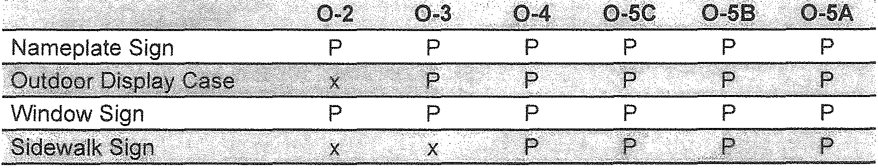

In addition to the sign types permitted in Tables 06.05A and 06.058, one ground sign may be placed per lot in accordance with the standards of Section 06.06(4).

* 1. STANDARDS FOR SPECIFIC SIGN TYPES

1. Awning Sign

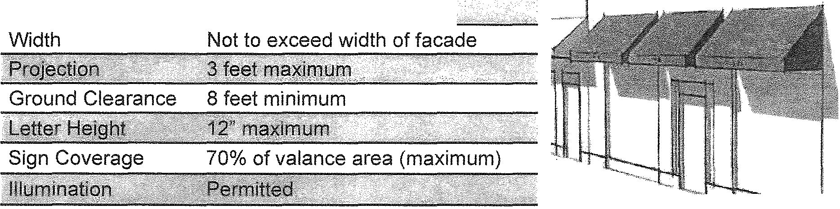

f?i .t;>,r infl ......·.. .1·· mr:fr!)}n@SJ *gr* \t\lim'@,\i\!" ...

1. Band Sign

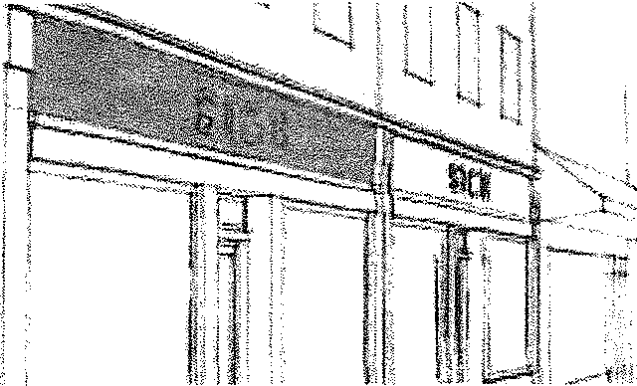

llf11P 1t e.rrooJft



Height 2 feet maximum



Sign Width 90% of facade (maximum)



3. Projecting Sign

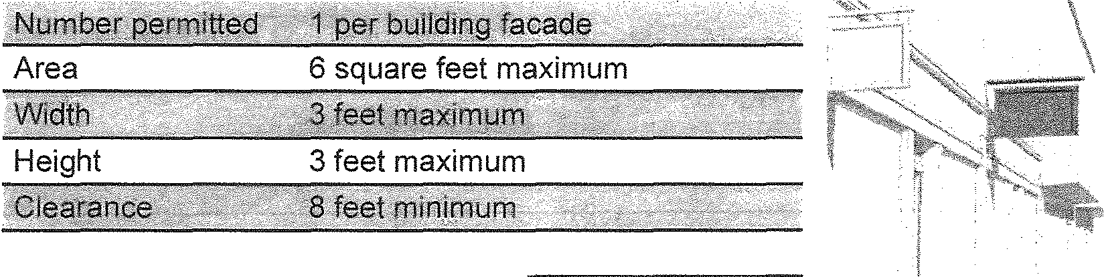

Illumination

Not permitted

1. Ground Sign



Area

25 square feet maximum

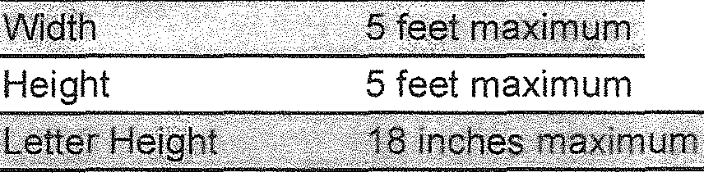

Illumination

Permitted

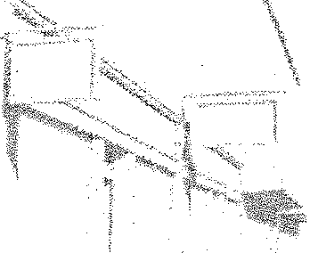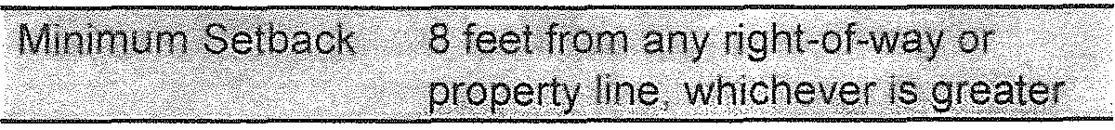 

* 1. Additional Standards for ground signs:
     1. Ground signs are only permitted on lots that have frontage on M-139.
     2. There is no minimum setback for signs located on M-139 between emon Creek Road and George Street; provided that such signs be located at least 8 feet from the edge of the road and are not located within the road right-of-way.
     3. Ground signs shall have no more than thirty (30) inches of clearance from the bottom of the sign to the ground below.
     4. For ground signs located more than 50 feet from the edge of the pavement of primary thoroughfare, the maximum sign height and area are as follows:
        1. Sign height may be increased by one foot for each ten (10) feet the sign is set back from the edge of the pavement beyond 50 feet. In no case shall a sign exceed eight (8) feet in height.
        2. Sign area may be increased by five square feet for each ten (10) feet the sign is set back from the edge of the pavement beyond 50 feet. In no case shall a sign exceed 48 square feet in area.
        3. On lots containing nonconforming principal buildings in terms of front setbacks, and for all lots west of Lemon Creek Road, the width of ground signs may be in­ creased to a maximum of eight (8) feet provided that the height does not exceed five (5) feet.

5. Marquee Sign



Width Shall not extend more than 2 inches

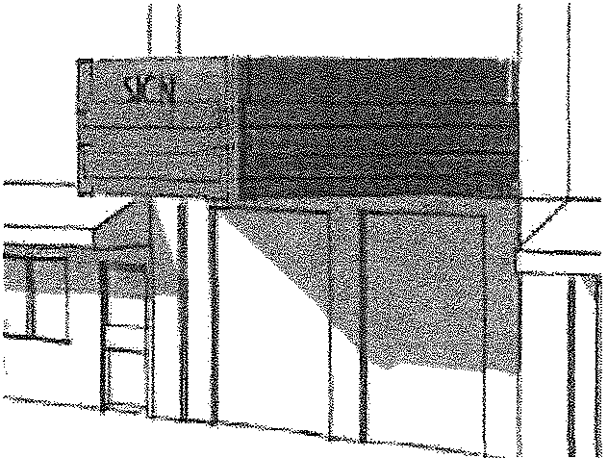

### ..,...,......,...,........,.,......., ....,,,.,....,.,.,,..,,,...,

on each side of the primary entrance



Projection

10 feet maximum



Clearance 1O feet minimum



6. Wall Sign



Area 50 square feet maximum for conven­ tional wall signs

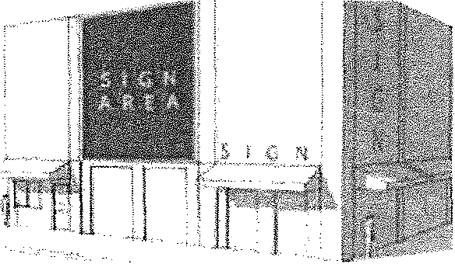

Painted wall signs shall not exceed 100 square feet or 20% of the wall area upon which they are painted. S!siall not ext$fia be·yiiJnd·fofline Qf ·



£li 1BJrJ:1 .fili fu it is ffi'\GJ

Illumination Permitted

1. Nameplate Sign



Width

18 inches maximum



Projection

3 inches maximum

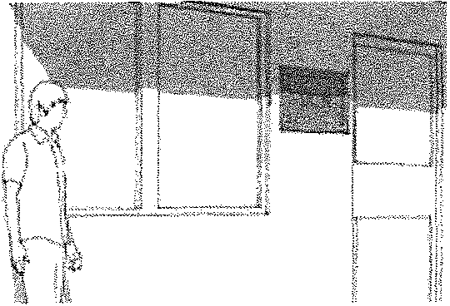

Additional standards for nameplate signs:



* 1. Nameplate signs must be located within 10 feet of the entrance to the building for which it advertises.

1. Outdoor Display Case

m r r:;ierrot t.t?: t§

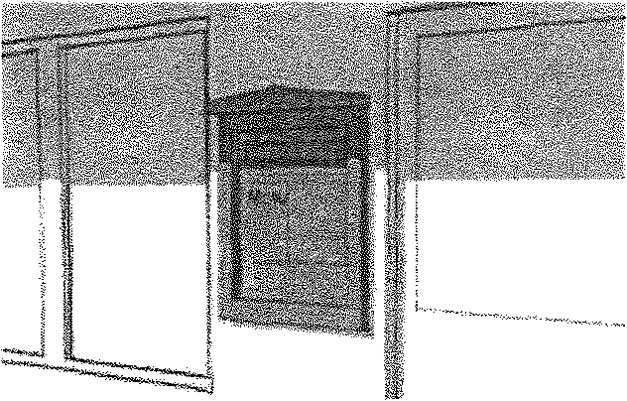

Area 6 square feet



Width 3 feet maximum



Illumination Permitted (internal only)

9. Window Sign

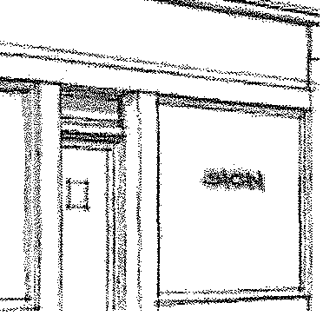



Area 25% of glass (maximum)



Illumination Not permitted

1. Sidewalk Sign

'4m!De.ro;:rp fffl:e . 1 f .!J .

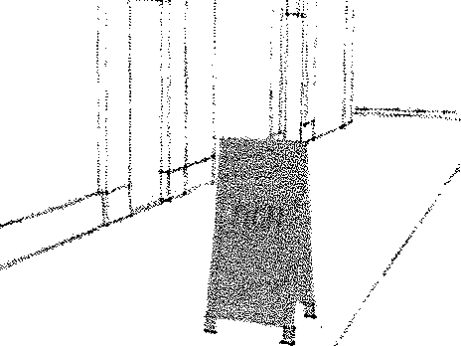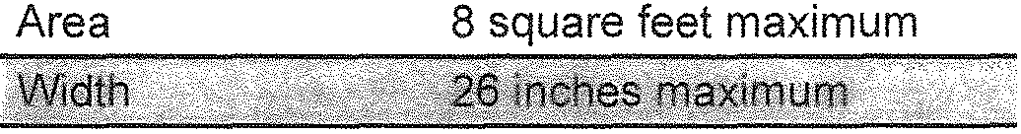

Height

42' maximum--=--,..,..,,.,.,...,...,.,.,..-....,.......,.....,.......,.._

Additional Standards for sidewalk signs:



* 1. Sidewalk signs shall be removed when the store for which it advertises is closed and during inclement weather so as not to constitute a hazard to public safety.
  2. Sidewalk signs shall not be located in the sidewalk in a manner that obstructs pedestrian travel or vehicular vision.

### GENERAL SIGN PROVISIONS

1. All signs shall conform to all applicable codes and Ordinances of the municipality in which it is located. A permit shall be required in accordance with the regulations of the applicable municipal Zoning Ordinance.

1. Illumination. When illumination is permitted, the following standards shall apply:
   1. Illumination shall not be flashing, blinking, intermittent, or an on-and-off type of lighting.
   2. Illumination shall be arranged so that light is deflected away from adjacent properties and any public right-of-way, and so that no direct sources of light are visible to any motorist or pedestrian located in a public right-of-way or street easement or from any adjacent prop­ erty.
   3. Any external lighting of signs shall be downward facing or otherwise directed to illuminate only the sign face.
   4. Internal illumination of signs is prohibited.
2. Sign Area. The area of a sign shall be measured within a single, continuous rectilinear pe­ rimeter composed of straight lines which encloses the extreme limits of the advertising mes­ sage, together with any frame or other material or color forming an integral part of the display, message, drawing, or similar device, or used to differentiate the same from the background against which it is placed, excluding the necessary supports, braces and/or uprights of the sign.

When two (2) sign faces are placed back-to-back, so that both faces cannot be viewed from any one point at the same time, and when such sign faces are part of the same sign structure and are not more than twenty-four (24) inches apart at any point, the sign area shall be com­ puted by the measurements of one (1) of the faces.

1. Sign Height. The height of a sign shall be measured as the vertical distance from the highest point of the sign to the mean grade of the ground immediately beneath the sign.
2. The following sign types not regulated by this Ordinance may be permitted pursuant to appli­ cable local restrictions and regulations:
   1. Political signs
   2. Portable and temporary signs

C. Electronic signs/electronic message boards, provided they are part of a ground sign that meets the standards of this Place Based Code.

All other signs not expressly permitted or exempted by this Place Based Code are prohibited.



### CHAPTER 7 DEFINITIONS

07.01 APPLICABI LITY

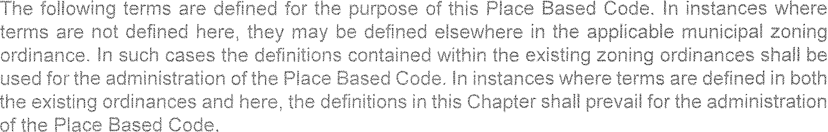

Civic Spaces

Park

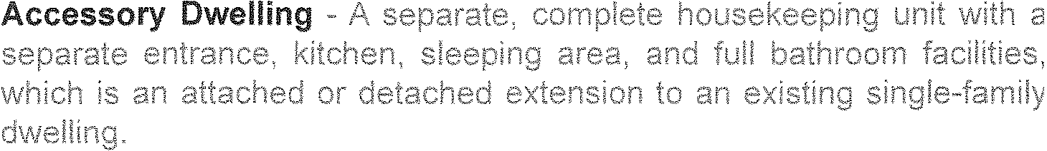

 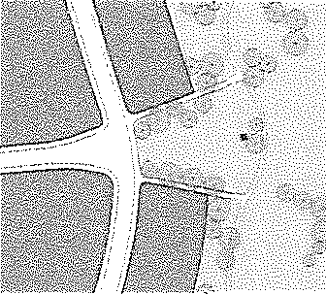

Green

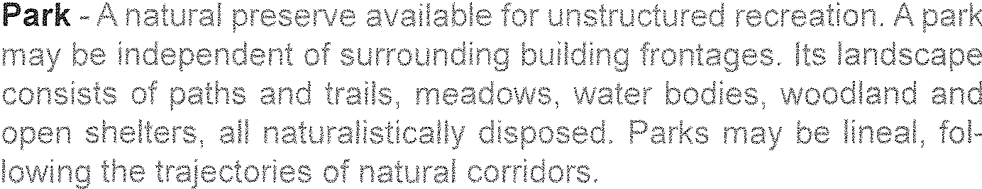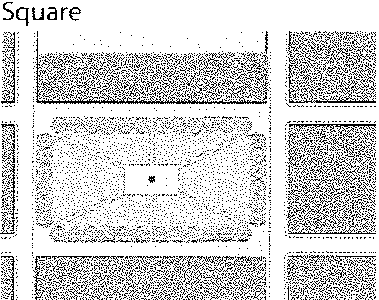

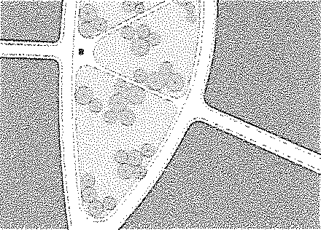

Plaza

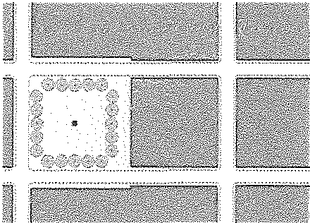



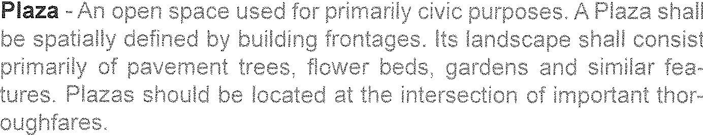 Playground

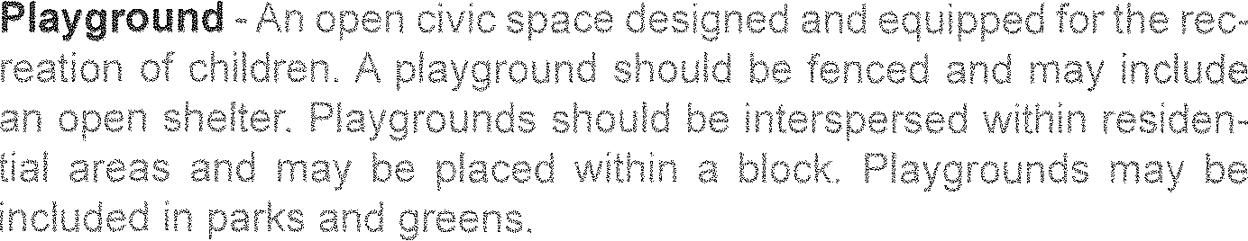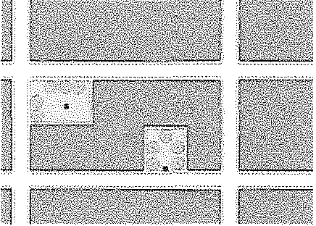

Linear Greenway

 



#### Frontage Types

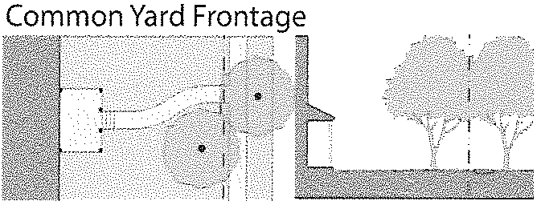

 Porch and Fence Frontage



Frontage -

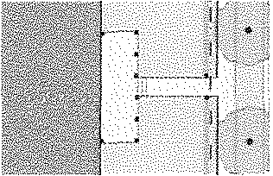

 Terrace or Ligtwell Frontage 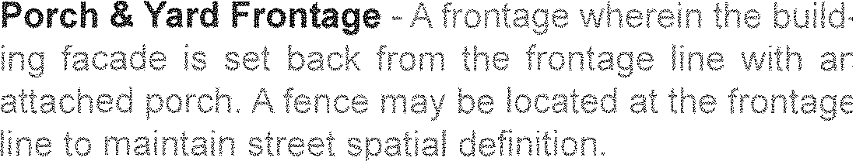 Forecourt Frontage

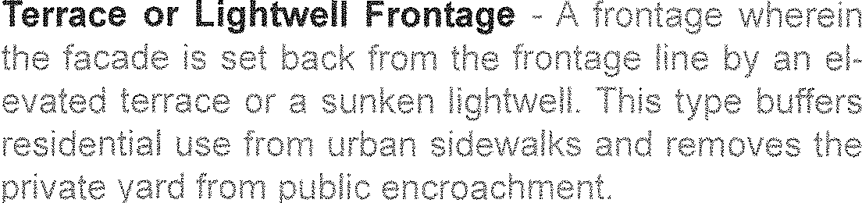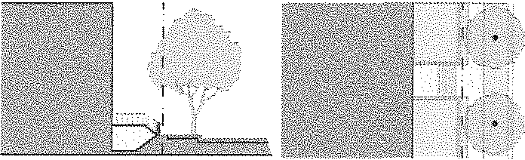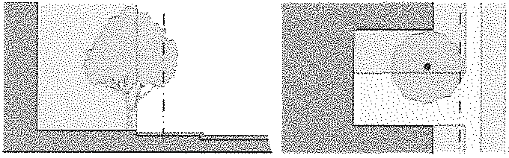

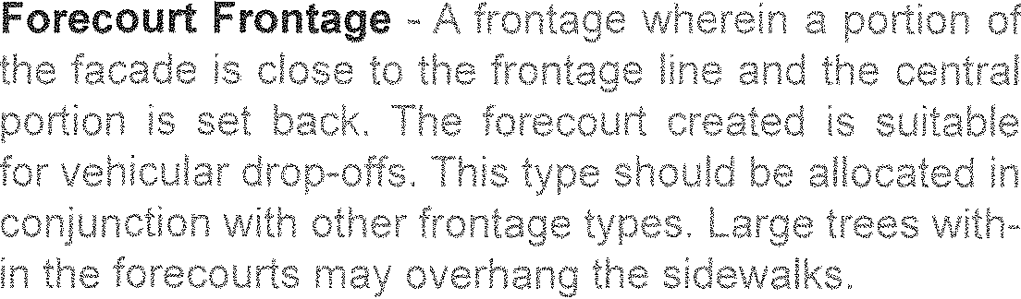 Shopfront Frontage 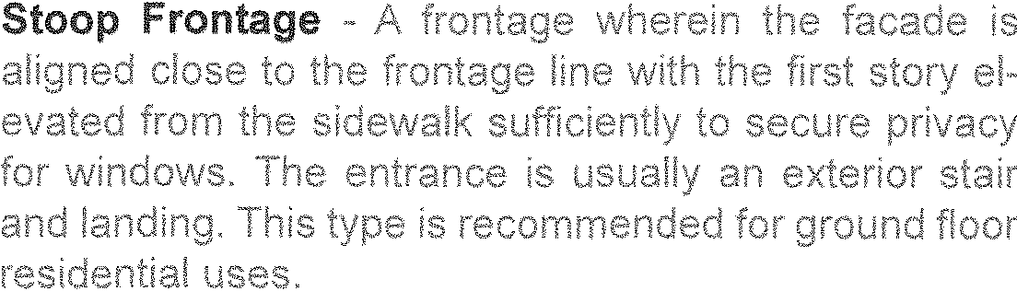 Gallery Frontage

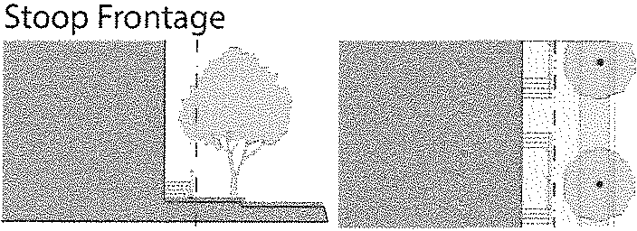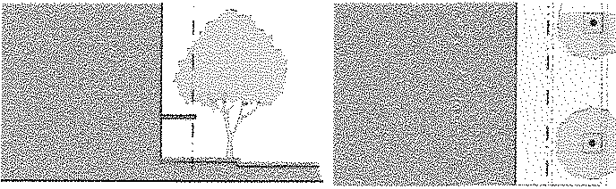

I

Arcade Frontage









#### Horizontal Proportion -- Lot line, front ,,



























Marquee 











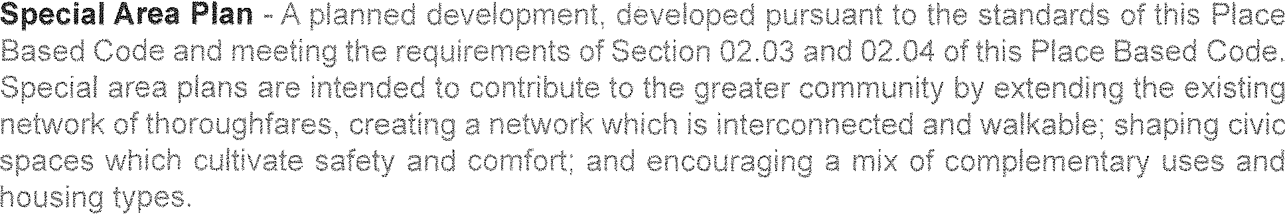









Road -













Vertical Proportion







### Section 2. Prior Ordinances.

All other ordinances or parts of ordinances in conflict with or superseded by this Ordinance are repealed except to the extent that any project, condition, violation or prosecution that was subject to the prior ordinance shall continue.

Section 3. Severability.

If any section, subsection, sentence, clause or phrase of this Ordinance is, for any reason, held to be unconstitutional, unlawful or unenforceable by a court of competent jurisdiction, such decision shall not affect the validity of the remaining portions of this Ordinance.

Section 4. Effective Date.

This Ordinance shall take effect twenty (20) days after publication. Section 5. Publication.

The Village Clerk shall certify to the adoption of this Ordinance and cause the same to be published as required by law.

YEAS: Bob Caulpetzer, Barry Gravitt, Sandy Swartz and President Milt Richter. NAYS: None.

ABSENT: Trustees: Jim Allred, Lonna Johnson and Lance Parrish.

Dated: September 8, 2015 



Ordinance declared adopted:

Certification

I hereby certify that the above and foregoing Ordinance was duly adopted by the Village Council of Berrien Springs and published in the *Journal Era,* a weekly newspaper published in the Village of Berrien Springs, in the issue of said newspaper dated and published on the 16th day of September, 2015.

